Do Now
Integrating SEL Throughout the Day

Take a few minutes to list all the ways that social-emotional learning is practiced (intentionally or unintentionally) throughout the day in your classroom.

Revisiting the Core Competencies
Integrating SEL Throughout the Day

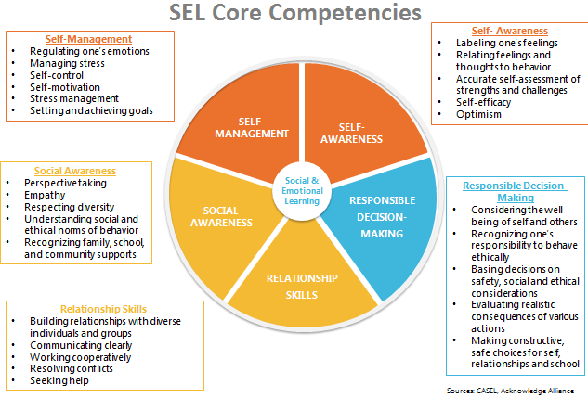

Evidence of Social-Emotional Learning
Integrating SEL Throughout the Day

As you watch the video, take notes on the following question:
Where do you see evidence of children practicing social-emotional skills?
Notes: | Aligned Competency/Competencies

Social-Emotional Teaching
Integrating SEL Throughout the Day

Teachers promote social and emotional learning through a variety of activities and practices, some purposeful and planned, some naturally occurring.

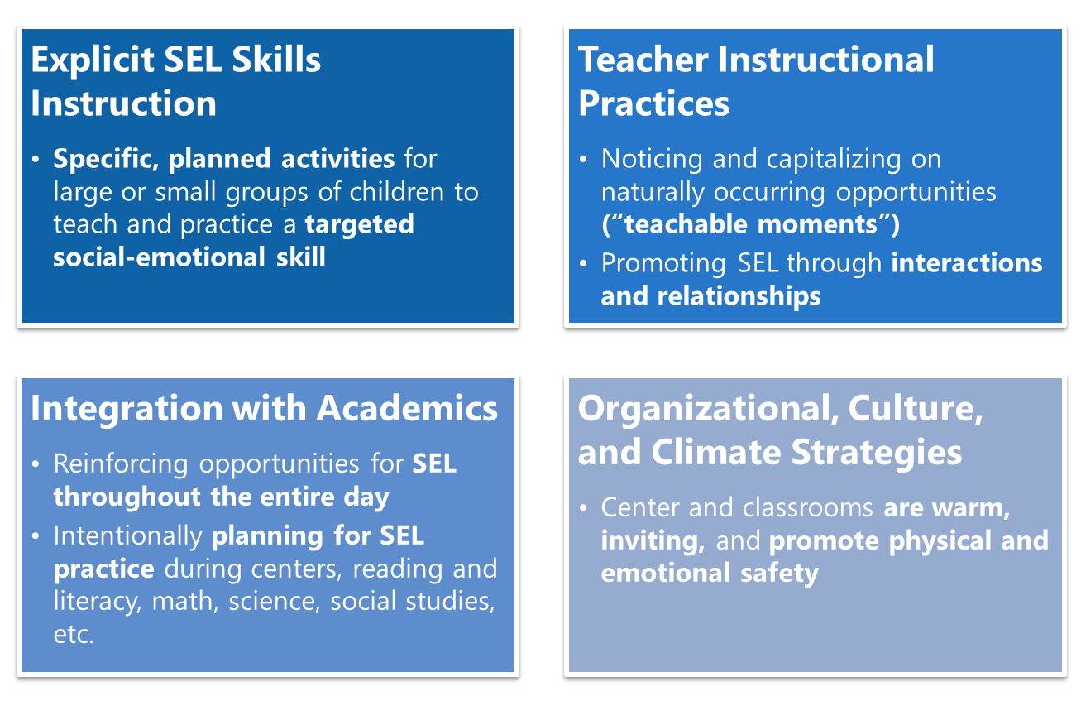

Integration with Academics
Integrating SEL Throughout the Day

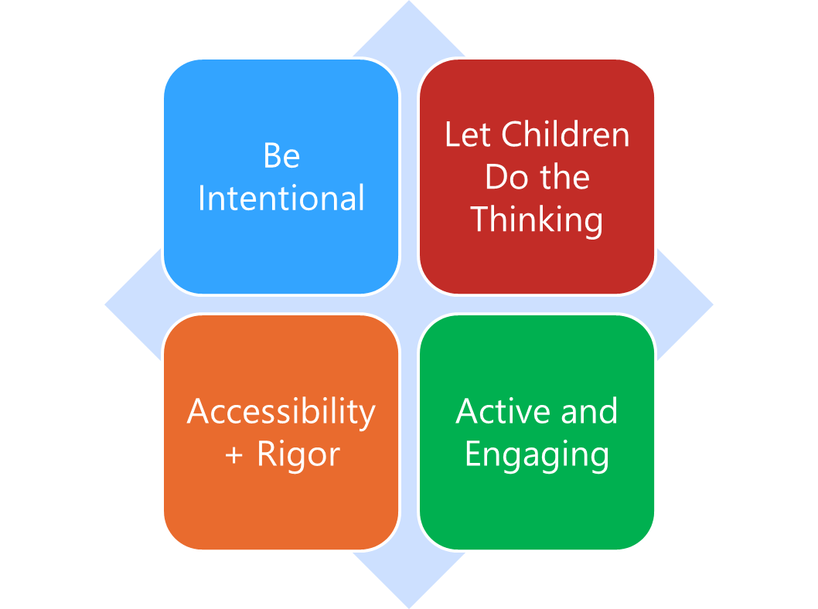

Integration with Academics refers to the essential practice of teaching children academic content and social-emotional skills in an intentionally interwoven way throughout the day. Teachers know the importance of teaching the whole child, and that no learning happens in a vacuum. The more we intentionally integrate SEL opportunities thoughtfully within other learning opportunities during the day, the better practice children will get across all their skills.
- Be intentional: Social and emotional skills come up all the time — at recess, in group work, in center time, during morning meeting. Be intentional about identifying opportunities to practice the skills with children, and build targeted skills into plans to best maximize those opportunities. Social-emotional learning opportunities are already going to be there in everything our children are doing and learning—it’s up to teachers to name those skills for children, and purposefully build opportunities for children to learn social-emotional skills while also engaging in learning across other domains.
- Let Children Do the Thinking: When integrating SEL with other content areas and parts of the day, make sure the majority of learning opportunities give children the chance to practice and engage with social-emotional skills. Teachers should still model, role play, provide language, etc. as necessary, but don’t over-intervene; give children chances to practice, make mistakes, self-correct, and problem solve!
- Accessibility+Rigor: Make sure learning opportunities are always accessible to children in developmentally-appropriate ways, but also challenge children to grow, try, and learn new things—in more academic areas and in social-emotional skill development! This could mean having choice for how to engage in particular activities, how much teacher support is provided during different learning times, etc.
- Active and Engaging: As with all learning in our early childhood classroom, the learning of content and social-emotional skills should be hands-on, active, and fun!

Remember: “SEL isn’t one more thing on the plate—it IS the plate.”

Integrating SEL and Academics: An Example
Integrating SEL Skills Throughout the Day

Clip 1:
Where do you notice the principles of integration with academics in this quick video?
Be Intentional
Let Children Do the Thinking
Accessibility + Rigor
Active and Engaging

Clip 2:
As you watch the video, take notes on where you specifically see the integration of academic learning and exploration with the building of social-emotional skills.

Reflection
Integrating SEL Throughout the Day

How are you already integrating SEL within academics? Where do you need more support?

What opportunities to integrate SEL with academics exist over the course of a typical day in your classroom?

Planning to Integrate SEL and Academics
Integrating SEL Throughout the Day

Think of your classroom, and independently brainstorm:
- In your classroom, what are the biggest opportunities to intentionally integrate SEL with academics?
- What strategies could you use to incorporate SEL more intentionally into those opportunities?
- Which SEL competencies would children be practicing?
Be prepared to share your thinking in small groups!

Time of Day (centers, read aloud, small groups, independent play, etc.) | How to intentionally integrate SEL with other learning? | Which SEL competencies most align?

“What’s Learned Here, Leaves Here”
Integrating SEL Throughout the Day

What are your biggest take-aways from this session?

How will you carry this learning forward in your own work?

