Nevada SEL Series
Session 1

Reflect
Why SEL Now More Than Ever

Spend the next several minutes individually reflecting on how you have been processing, responding to, and coping with the challenges we are facing as early childhood educators and members of our larger communities during the Covid-19 crisis.

Do Now
Understanding the Development of Social-Emotional Skills

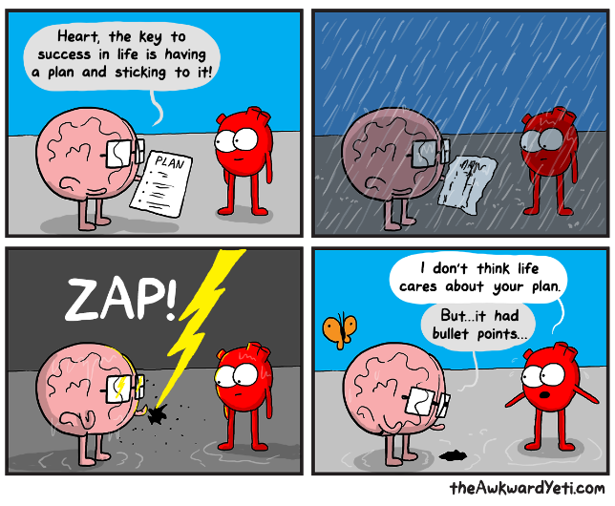

Read the cartoon above and respond to the following questions:
- What ARE the key traits/attitudes/mindsets/ skills to being successful in life?

- What traits would you identify as most important when you need to “weather a storm”?

SEL is…
Understanding the Development of Social-Emotional Skills

“Social and emotional learning (SEL) is an integral part of education and human development. SEL is the process through which all young people and adults acquire and apply the knowledge, skills, and attitudes to develop healthy identities, manage emotions and achieve personal and collective goals, feel and show empathy for others, establish and maintain supportive relationships, and make responsible and caring decisions.
SEL advances educational equity and excellence through authentic school-family-community partnerships to establish learning environments and experiences that feature trusting and collaborative relationships, rigorous and meaningful curriculum and instruction, and ongoing evaluation. SEL can help address various forms of inequity and empower young people and adults to co-create thriving schools and contribute to safe, healthy, and just communities.”

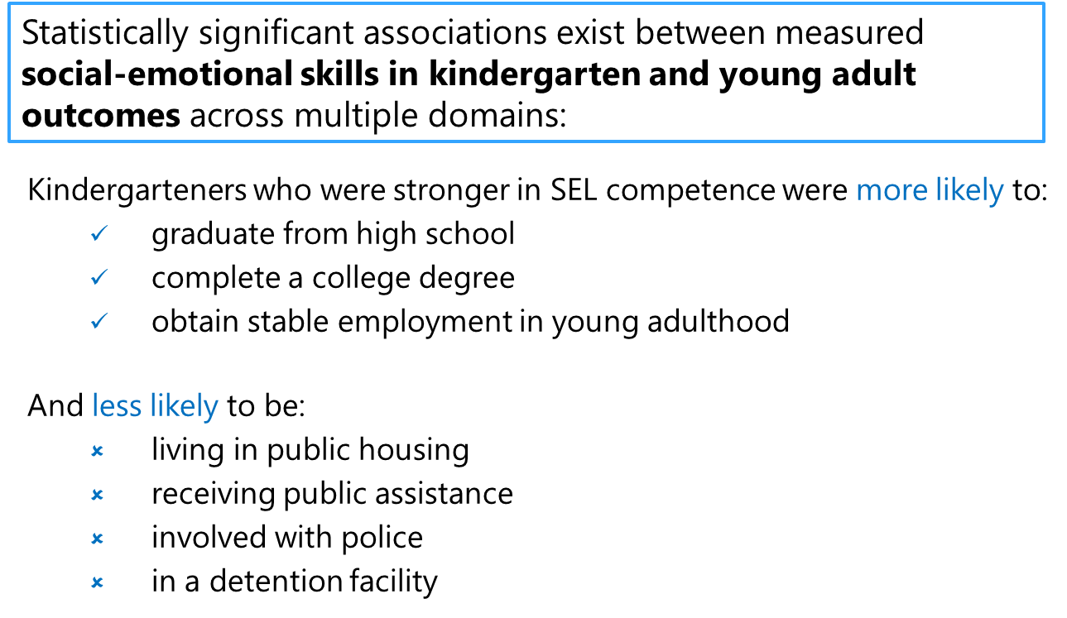
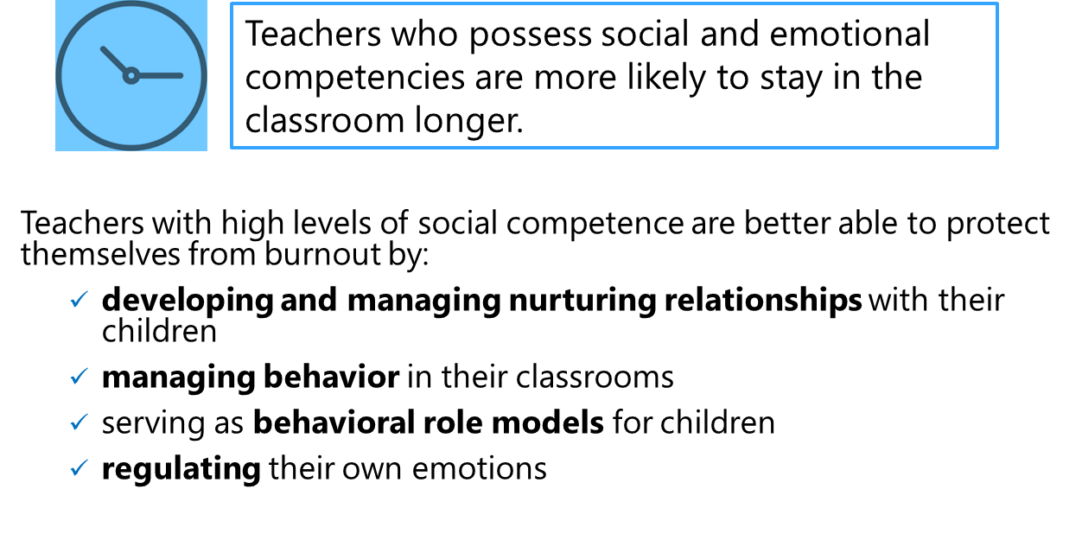

Brain Architecture: We Are Laying the Foundation
Understanding the Development of Social-Emotional Skills

As you listen to this clip from “The Brain Architects” podcast, jot down anything that jumps out to you.
(Link: https://developingchild.harvard.edu/resources/the-brain-architects-podcast-brain-architecture-laying-the-foundation/)

Reflection: What are the implications for your work as an early childhood leader as you consider laying a strong foundation for children in the earliest years?

The Five SEL Competencies
Understanding the Development of Social-Emotional Skills

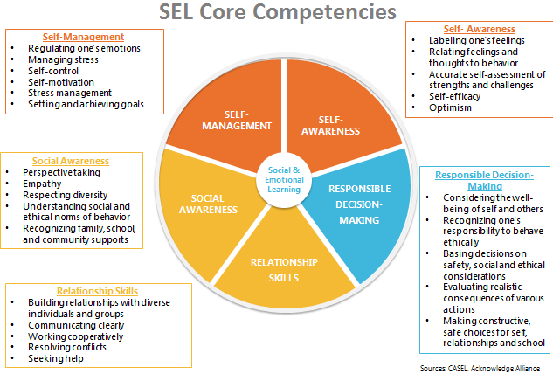

Reflecting on the Developmental Trajectories
Understanding the Development of Social-Emotional Skills

What SEL competencies do you feel you understand deeply already? Which areas will you need to keep in mind the most?

How might mapping developmental trajectories be helpful to your teachers? What might be challenging?

SEL in Action
Understanding the Development of Social-Emotional Skills

SEL Clip 1:
- What evidence do you see of the five SEL competencies in action, from the teacher and/or children?

- How do you notice teachers supporting children along the developmental continuum of social-emotional learning?

SEL Clip 2:
- What evidence do you see of the five SEL competencies in action, from the teacher and/or children?

- How do you notice teachers supporting children along the developmental continuum of social-emotional learning?

Exit Ticket
Understanding the Development of Social-Emotional Skills

Reflect on the following questions:
- How can we use the science of the developing brain to support our children in our centers?

- How does understanding the developmental trajectory of social-emotional skills support teachers and leaders in interactions with and instruction of children?

Do Now
Trauma-Informed Teaching in ECE: Part 1

Read the Fred Rogers quote above and reflect on the following:

- What are some of the things our children may have gone through in the past few months?

- What do they need from us, as early childhood educators, right now?

How Trauma Affects Health
Trauma-Informed Teaching in ECE: Part 1

As you watch the video clip, record the things that stand out to you below:

Common Definitions
Trauma-Informed Teaching in ECE: Part 1

Trauma/Adverse Childhood Experiences (ACEs): Adverse childhood experiences, or ACEs, are potentially traumatic events that occur in childhood (0-17 years).
For example:
- experiencing violence, abuse, or neglect
- witnessing violence in the home or community
- having a family member attempt or die by suicide
Also included are aspects of the child’s environment that can undermine their sense of safety, stability, and bonding such as growing up in a household with:
- substance misuse
- mental health problems
- instability due to parental separation or household members being in jail or prison
What experiences might be traumatic?
- Physical, sexual, or psychological abuse and neglect (including trafficking)
- Physical and/or emotional neglect
- Natural and technological disasters, catastrophes, or terrorism
- Family or community violence
- Sudden or violent loss of a loved one
- Substance use disorder (personal or familial)
- Refugee and war experiences (including torture)
- Serious accidents or life-threatening illnesses
- Military family-related stressors (e.g., deployment, parental loss or injury)

Toxic Stress
Trauma-Informed Teaching in ECE: Part 1

Toxic stress explains how ACEs “get under the skin” and trigger biological reactions that lead to those outcomes.
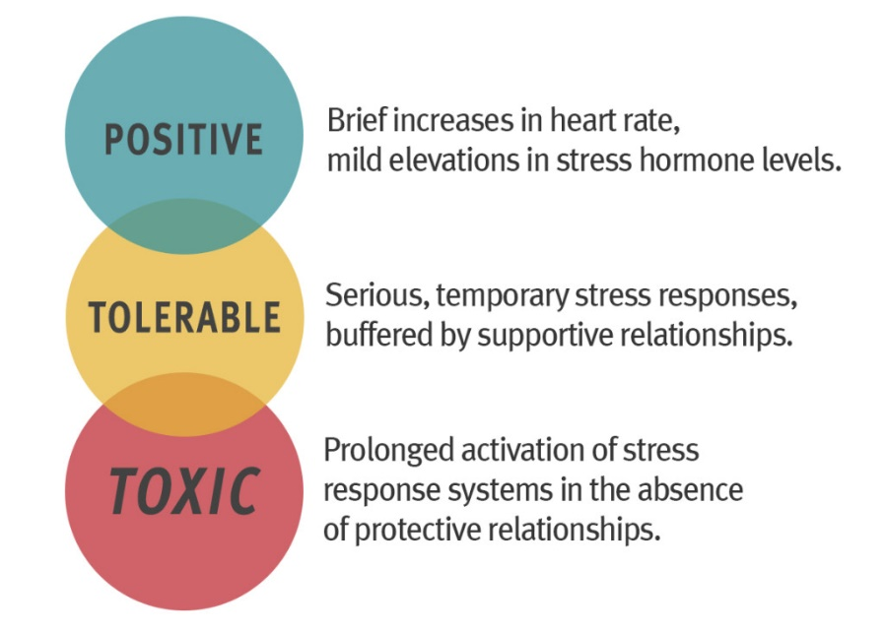

Take 3 minutes to independently reflect:
- How does understanding the brain science of trauma in early childhood make you a better leader? How can it make your teachers better equipped to support their children?

Expressions of Trauma in Early Childhood Classrooms
Trauma-Informed Teaching in ECE: Part 1

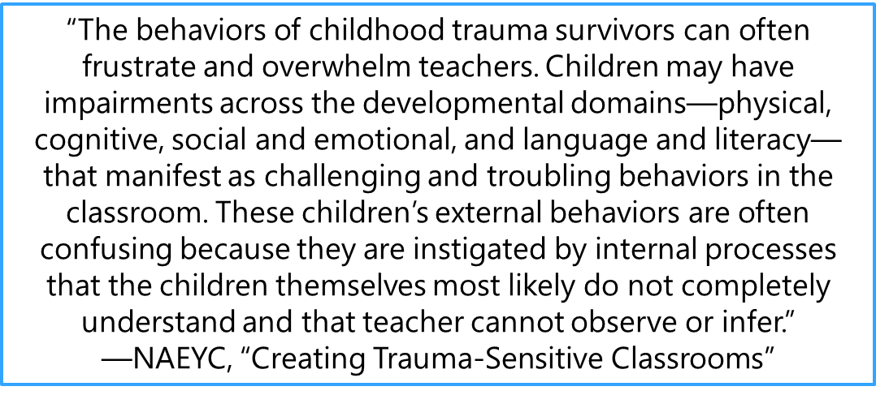
Social Emotional Regulation
A child who has experienced trauma may:
- Be overwhelmed by feelings of fear and stress (brains remain in a state of hyperarousal)
- Have a difficult time regulating their emotions and controlling impulses
- Behave aggressively towards themselves or others
- Misunderstand or be unable to identify the facial and body expressions of others

Language and Communication
A child who has experienced trauma may:
- Struggle to communicate thoughts, feelings, and empathy
- Use and understand primarily “instrumental language” to direct and command behavior (“sit down”, “come here”, “be quiet”, etc.)
- Appear demanding and inflexible
- Communicate using physical responses (hitting, biting, etc.) and/or tantrums

Building Relationships
A child who has experienced trauma may:
- Struggle to interact successfully with peers and teachers
- Not know how to identify and express their feelings with appropriate words
- Keep others at a distance as a way to emotionally, and even physically, protect themselves

Play
A child who has experienced trauma may:
- Struggle to engage in imaginative and creative play
- Become overwhelmed by feelings that emerge during imaginative play
- Avoid initiating play and struggle to resolve conflicts that arise during play

How Do We Move Forward?
Trauma-Informed Teaching in ECE: Part 1

ACEs are preventable. Creating and sustaining safe, stable, nurturing relationships and environments for all children and families can prevent ACEs and help all children reach their full potential.
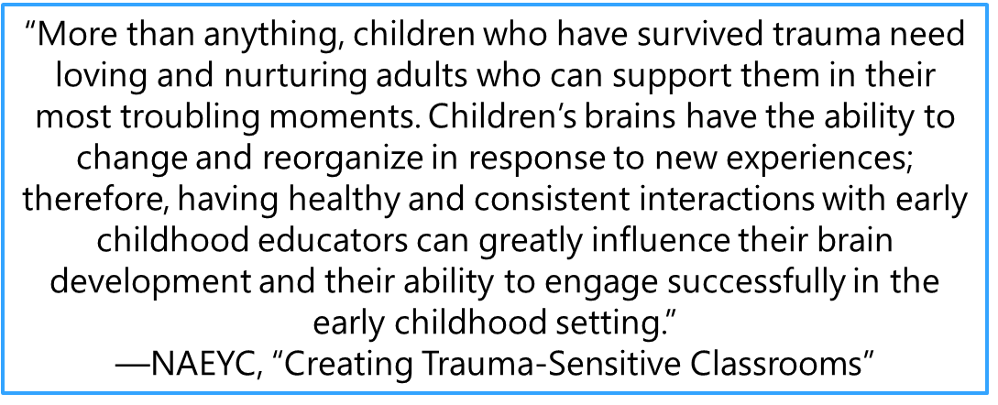
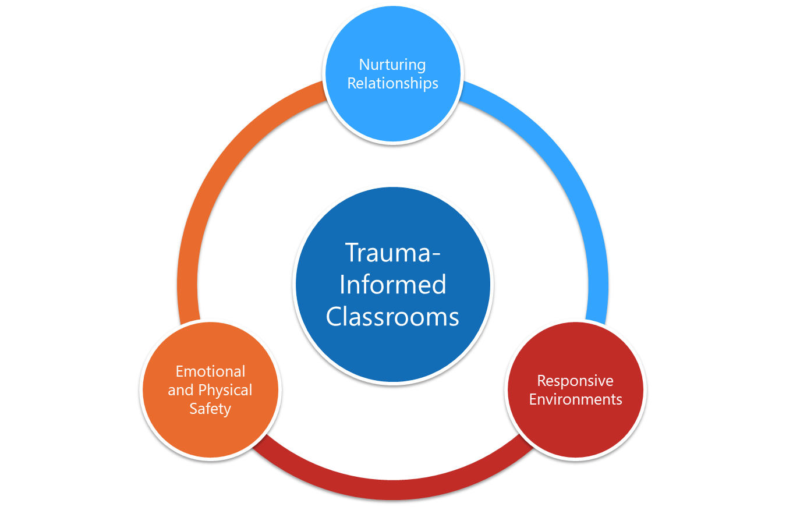

Creating Trauma-Sensitive Classrooms: Emotional Safety
Trauma-Informed Teaching in ECE: Part 1

Safety is a PREREQUISITE.
Emotional Safety: Children experience consistency, safety, and respect.
- Create a space to build relationships
- Transfer power to children and families
- View parents as individuals who have had their own experiences, a child as part of a family, and a family as part of a community.
- Respect diversity through sensitivity to cultural norms, rituals, and parenting styles
Serve and Return Interactions:
As you watch the video, take notes on the five steps of Serve and Return interactions in the table below.
Step | Description | Notes
1 | Notice the serve and share the child’s focus of attention
2 | Return the serve by supporting and encouraging
3 | Give it a name!
4 | Take turns…and wait. Keep the interactions going back and forth
5 | Practice endings and beginnings

Connecting Trauma-Informed Teaching to SEL
Trauma-Informed Teaching in ECE: Part 1

In what ways does social-emotional learning interact and overlap with trauma-informed teaching? How can serve-and-return interactions support both?

What’s Learned Here, Leaves Here
Trauma-Informed Teaching in ECE: Part 1

Take the next several minutes to create a plan for how you will take this content or this morning’s content back to your team.
- When will you deliver this content to your staff?

- How will you deliver content to your staff? (One whole-group professional development? Smaller groups?)

- What challenges do you anticipate your staff may have with this content?

Next Steps
Closing and Reflection

Prior to our next training:
- Complete the self-assessment survey included in the follow-up email by EOD Thursday, November 19th.
- Share SEL survey (link coming in follow-up email) with teachers by EOD Thursday, November 19th.
- Deliver either of today’s content sessions (“Understanding the Development of Social-Emotional Skills” or “Trauma-Informed Teaching in ECE: Part 1”) to staff members.
  - Collect artifacts of teacher learning and/or Exit Tickets from teachers and bring that data to our December training.

