Nevada SEL Series
Session 2

Personal Check-In
Opening and Reflection

Spend the next several minutes silently journaling in response to the questions below:
- Where am I emotionally today? What is fueling those emotions? How is my body physically responding to those emotions? (Pro tip: Check in with, but don’t dive into, your emotions. As you’re looking at yourself and assessing how you feel, back up a little. Consciously ‘look at’ your feelings as if you were viewing them from the outside. The goal is to acknowledge your emotions. Allow them to inform you, not overwhelm you.)

- What do I most need from my colleagues today, to successfully engage in the work ahead of me?

- What do I need to do to take care of myself today, so I can successfully engage in the work ahead of me?

Do Now
Building Social-Emotional Skills

In our opening session, you were asked to do some independent reflection, small group sharing, and whole group sharing. Think closely about what you needed to be able to do to be successful in those activities, then respond to the questions below:
- What self-awareness skills did you need to engage successfully in our opening session?

- What self-management skills did you need to engage successfully in our opening session?

Setting the Stage
Building Social-Emotional Skills

As you watch the TedTalk from Dr. Rosemarie Allen, take notes on the following:
- How are adults responsible for the teaching and modeling of self-awareness and self-management skills?

- How do (or should) adults rely on their own social-emotional skills to support children?

- Why is it essential to teach instead of punish?

Revisiting the Core Competencies
Building Social-Emotional Skills

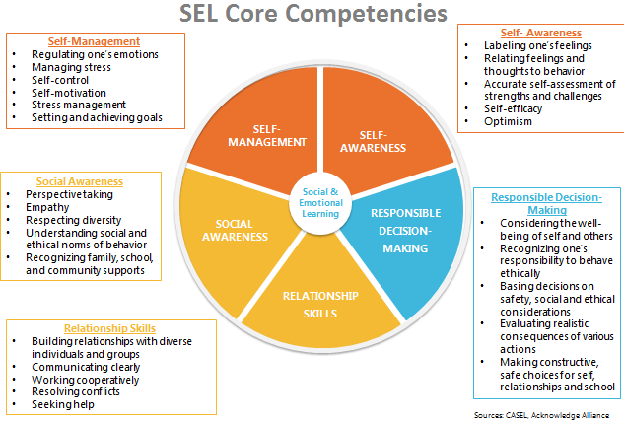

Self-Awareness
Building Social-Emotional Skills

As you watch the video, jot down notes on anything that stands out for you. Look especially for the key features of self-awareness, and why self-awareness skills are important throughout a child’s entire life.

Self-Awareness: The ability to accurately recognize one’s own emotions, thoughts, and values and how they influence behavior across contexts. The ability to accurately assess one’s strengths and limitations, with a well-grounded sense of confidence, optimism, and a “growth mindset.”
Self-Awareness includes:
- Identifying emotions
- Accurate self-perception
- Recognizing strengths
- Self-confidence
- Self-efficacy
- Identifying personal, cultural, and linguistic assets
- Linking feelings, values, and thoughts
- Having a growth mindset
- Developing interests and a sense of purpose

Self-Management
Building Social-Emotional Skills

As you watch the video, jot down notes on anything that stands out for you. Look especially for the key features of self-management, and why self-management skills are important throughout a child’s entire life.

Self-Management: The ability to successfully regulate one’s emotions, thoughts, and behaviors in different situations — effectively managing stress, controlling impulses, and motivating oneself. The ability to set and work toward personal and academic goals.
Self-Management includes:
- Impulse control
- Stress management
- Organizational skills
- Managing one’s emotions
- Identifying and using stress management strategies
- Exhibiting self-discipline and self-motivation
- Setting personal and collective goals
- Showing the courage to take initiative

Identifying Self-Awareness and Self-Management
Building Social-Emotional Skills

Clip 1: Young Toddlers
As you watch the video, take notes on the following:
- Where do you see evidence of self-management and self-awareness in the video?

- What do the children demonstrate? How does the teacher reinforce these skills?

Clip 2: Preschool
As you watch the video, take notes on the following:
- Where do you see evidence of self-management and self-awareness in the video?

- What do the children demonstrate? How does the teacher reinforce these skills?

Reflection
Building Social-Emotional Skills

What stands out to you most about the teaching and learning of self-awareness and self-management skills?

Social-Emotional Teaching
Building Social-Emotional Skills

Teachers promote social and emotional learning through a variety of activities and practices, some purposeful and planned, some naturally occurring.

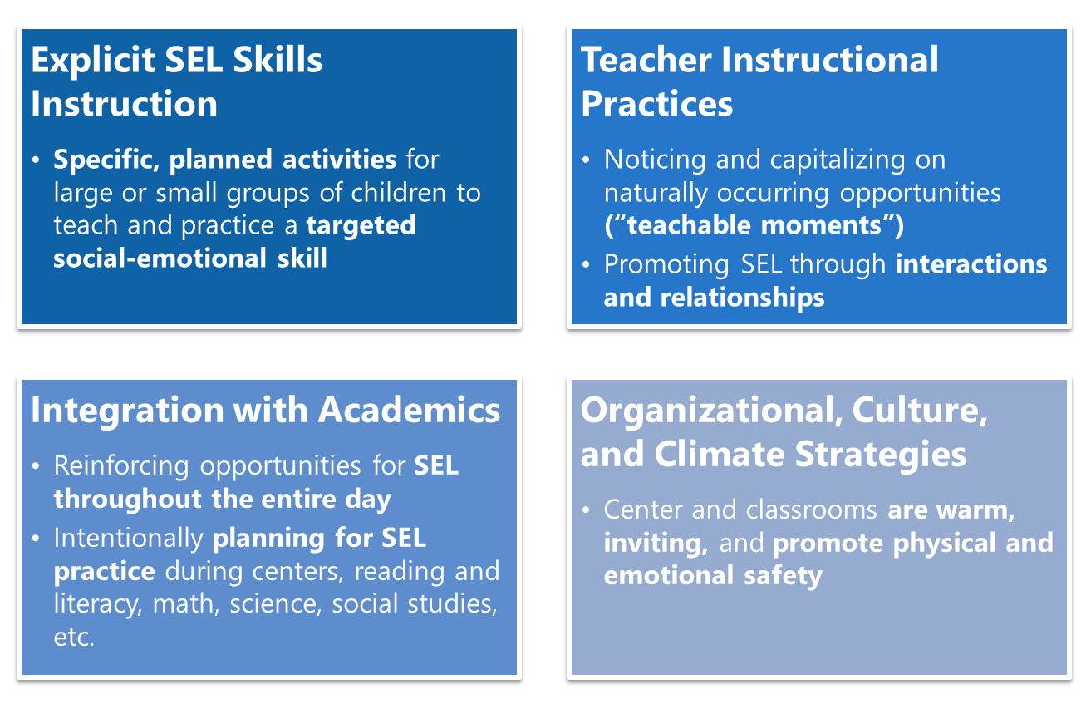

Putting the Pieces Together
Building Social-Emotional Skills

Consider each social-emotional teaching strategy through the lens of teaching self-awareness and self-management. What would you expect teachers to do to effectively teach self-awareness and self-management using each teaching strategy?
Explict sel skills instruction | teacher instructional practices
integration with academics | organizational, culture, & climate strategies

Reflection
Building Social-Emotional Skills

Respond to the following questions below.
What SEL teaching strategies do you and your teachers already use reliably?

What strategies will you need to be more intentional in implementing?

“What’s Learned Here, Leaves Here”
Building Social-Emotional Skills

What are your biggest take-aways from this session?

What are you most excited to share with your teachers?

How will you carry this learning forward in your own work?

Do Now
Trauma-Informed Teaching in ECE: Part 2

Sofia, 3 1/2 years old, has attended an early childhood center for two years without any behavioral or emotional problems; that is, until recently, when her community experienced extensive wildfires that destroyed or damaged about 20 percent of homes. Although Sofia’s home was not damaged, the store where her mother worked was destroyed. Sofia begins to protest when her mother leaves her at drop-off in the morning. Sofia frequently asks about her mother throughout the day, often going to the window to look for her. She starts to use baby talk and seems anxious and unable to rest at nap time. The staff provides consistent support and reassurance that her mother will return on time each day and reminds her when pick-up time is. They offer opportunities to draw and play with dolls. They notice that Sofia sometimes draws pictures of homes or trees burning and that, in her play, she makes the mother and father dolls argue, sometimes even having them threaten to leave each other. The staff talks with Sofia's mother, who becomes tearful. She shares that she and her husband have been arguing about money; she later speaks with her husband and they try not to argue when Sofia can overhear. Sofia has also been protesting going to bed alone, so her parents have been allowing her to sleep with them most nights. (from “Supporting Young Children After Crisis Events”)

Read the vignette above and reflect on the following:

- How does Sofia’s behavior change following the wildfires in her community? Why might she be exhibiting these new behaviors?

- What connections do you make between what Sofia has gone through and what your children have gone through during the pandemic?

“Getting Underneath” Child Behavior
Trauma-Informed Teaching in ECE: Part 2

Reflection
Trauma-Informed Teaching in ECE: Part 2

We are not clinicians or medical professionals, but it is still critically important we seek to understand the root of child behaviors.
What is your personal action step to better “get underneath” the behavior of children in your care?

Creating Trauma-Sensitive Classrooms
Trauma-Informed Teaching in ECE: Part 2

Physical safety is a prerequisite for trauma-informed classrooms. So how do we set up our environments to support ALL children?
(Physical safety: Children are free from potential harm and have some control over their environment.)
- Have a comfortable and welcoming environment:

- Orient children to their physical space:

- Create and maintain consistent daily routines:

- Anticipate difficult periods and transitions and offer extra support:

- Tell children when something out of the ordinary is going to occur:

- Use techniques to support children’s self-regulation:

- Offer children developmentally-appropriate choices:

- Understand that children make sense of experiences by reenacting them in play or interactions with peers and adults:

- Be nurturing and affectionate, but also sensitive to children’s individual triggers:

Connecting Trauma-Informed Teaching to SEL
Trauma-Informed Teaching in ECE: Part 2

In what ways does social-emotional learning, specifically self-awareness and self-management, support and overlap with trauma-informed teaching?

Planning to Implement Trauma-Informed Practices
Trauma-Informed Teaching in ECE: Part 2

Picture your school or center as it’s currently operating during COVID, or how it will operate when it reopens. To ensure that you’re applying what you’ve learned in the SEL course to ensure ALL children are returning to responsive classroom environments where they can feel safe, you need to be intentional with your planning.
Plan out:
- What specific actions will you take to ensure trauma-informed practices are being used proactively across your school or center?
- What will you ask teachers to do in their own classrooms to proactively apply trauma-informed best practices?
(Hint: Refer back to page 16 for best practices in setting up trauma-informed classrooms and spaces!)
Specific actions I, as a leader, will take to ensure trauma-informed practices are being used proactively in my center:

What I expect my teachers to do in their classrooms to apply trauma-informed best practices proactively:

What’s Learned Here, Leaves Here
Trauma-Informed Teaching in ECE: Part 2

Reflect and Plan.
- What content from this session do you want to make sure your teachers get, no matter what?

- How will you share this information (and/or this morning’s information) with them?

Next Steps
Closing and Reflection

Prior to our next training:
Deliver either of today’s content sessions (“Building Social-Emotional Skills: Self-Awareness and Self-Management” or “Trauma-Informed Teaching in ECE: Part 2”) to staff members.
- Collect artifacts of teacher learning and/or Exit Tickets from teachers and bring that data to our January training.

