Nevada SEL Series
Session 3

Personal Check-In
Opening and Reflection

Spend the next several minutes silently journaling in response to the questions below:
- Where am I emotionally today? What is fueling those emotions? How is my body physically responding to those emotions? (Pro tip: Check in with, but don’t dive into, your emotions. As you’re looking at yourself and assessing how you feel, back up a little. Consciously ‘look at’ your feelings as if you were viewing them from the outside. The goal is to acknowledge your emotions. Allow them to inform you, not overwhelm you.)

- What do I most need from my colleagues today, to successfully engage in the work ahead of me?

- What do I need to do to take care of myself today, so I can successfully engage in the work ahead of me?

Do Now
Building Social-Emotional Skills

In today’s session, we’ll be diving into interpersonal competencies: social awareness and relationship skills.
- What do children (and adults!) need to know to successfully engage in social interactions and build relationships?

- What do children (and adults!) need to be able to do to successfully engage in social interactions and build relationship?

Revisiting the Core Competencies
Building Social-Emotional Skills

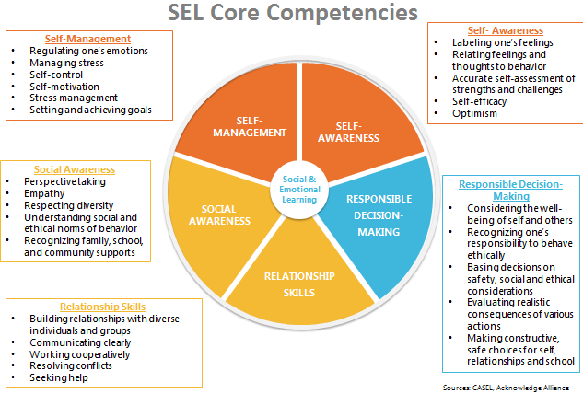

Social Awareness
Building Social-Emotional Skills

As you watch the video, jot down notes on anything that stands out for you. Look especially for the key features of social awareness, and why social awareness skills are important throughout a child’s entire life.

Social Awareness: The abilities to take the perspective of and empathize with others, including those from diverse backgrounds, cultures, and contexts. This includes the capacities to feel compassion for others, understand broader historical and social norms for behavior in different settings, and recognize family, school, and community resources and supports.
Social Awareness includes:
- Demonstrating empathy and compassion
- Appreciating diversity
- Respect for others
- Taking others’ perspectives
- Recognizing strengths in others
- Showing concern for the feelings of others
- Understanding and expressing gratitude

Relationship Skills
Building Social-Emotional Skills

As you watch the video, jot down notes on anything that stands out for you. Look especially for the key features of relationship skills, and why relationship skills are important throughout a child’s entire life.

Relationship Skills: The abilities to establish and maintain healthy and supportive relationships and to effectively navigate settings with diverse individuals and groups. This includes the capacities to communicate clearly, listen actively, cooperate, work collaboratively to problem solve and negotiate conflict constructively, navigate settings with differing social and cultural demands and opportunities, provide leadership, and seek or offer help when needed.
Relationship Skills include:
- Social engagement

- Communicating effectively

- Developing positive relationships

- Practicing teamwork and collaborative problem-solving

- Resolving conflicts constructively

- Seeking or offering support and help when needed

Identifying Social Awareness and Relationship Skills
Building Social-Emotional Skills

Clip 1: Toddlers
As you watch the video, take notes on the following:
- Where do you see evidence of social awareness and relationship skills in the video?

Clip 2: Preschool
As you watch the video, take notes on the following:
- Where do you see evidence of social awareness and relationship skills in the video?

- How does the teacher reinforce these skills?

Reflection
Building Social-Emotional Skills

What stands out to you most about the teaching and learning of social awareness and relationship skills?

Social-Emotional Teaching
Building Social-Emotional Skills

Teachers promote social and emotional learning through a variety of activities and practices, some purposeful and planned, some naturally occurring.

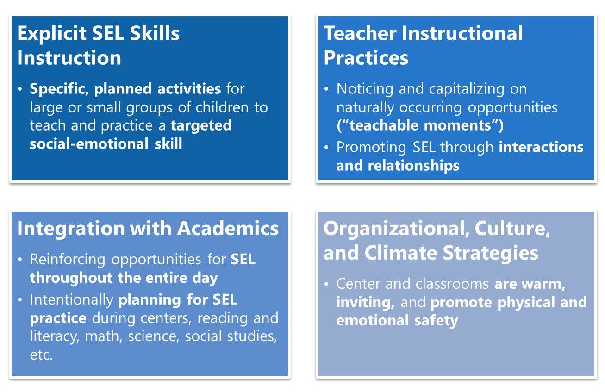

Explicit SEL Instruction
Building Social-Emotional Skills

Effective explicit SEL instruction has four elements represented by the acronym SAFE:
- Sequenced—connected and coordinated activities to foster skills development;
- Active—active forms of learning to help students master new skills;
- Focused—containing activities that clearly emphasize developing personal and social skills;
- Explicit—targeting specific social and emotional skills

Brainstorm: What specific interpersonal awareness and skills would we want to teach using explicit instruction? (Consult the developmental trajectories in the Google Doc for support.)

Sample Scope of Explicit SEL Instruction
Building Social-Emotional Skills

Sample Weekly Plan
Building Social-Emotional Skills

In what ways can we explicitly teach SEL skills each week? What components of this plan jump out to you?

Explicit SEL Skills Instruction: An Example
Building Social-Emotional Skills

As you watch the video, note:
- What are children learning about in this lesson?

- Where do you see evidence of the SAFE elements?

Reflection
Building Social-Emotional Skills

If you DO have an SEL curriculum—do your teachers use it effectively and regularly? If not, how can you support stronger implementation? If so, how can you continue to enhance that learning for children?

If you do NOT have an SEL curriculum—what can you do to support the explicit teaching of SEL skills across your classrooms? How can these principles still come to life in your school or center?

Planning for Explicit SEL Skills Instruction
Building Social-Emotional Skills

- With your partner(s), select an interpersonal skill to explicitly teach to children.
- Design a brief lesson (or lessons!) that explicitly teaches that skill to children. Keep the SAFE principles in mind!
- Be prepared to share your lesson idea with the whole group!

Interpersonal Skill:
Lesson Plan:

“What’s Learned Here, Leaves Here”
Building Social-Emotional Skills

What are your biggest take-aways from this session?

What are you most excited to share with your teachers?

How will you carry this learning forward in your own work?

Do Now
Trauma-Informed Teaching in ECE: Part 3

Think about your own experience in coping with the new realities that have come with the coronavirus pandemic.

- What emotional and physical responses have you experienced in the past four months?

- How have you managed those responses? How have you relied on others to help you?

Managing Hardship in the Time of COVID
Trauma-Informed Teaching in ECE: Part 3

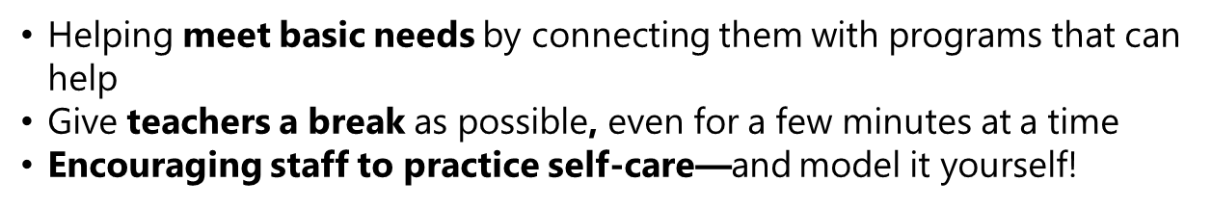

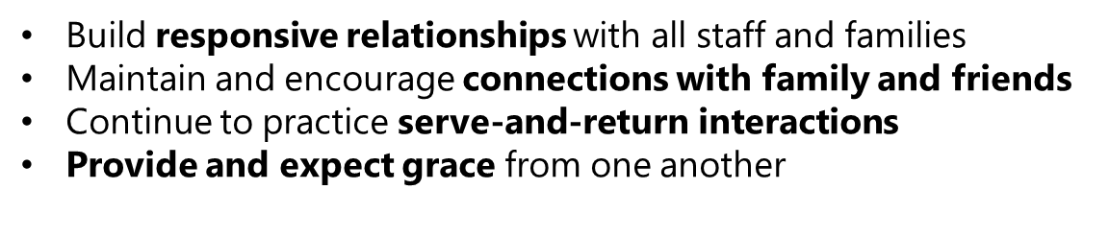
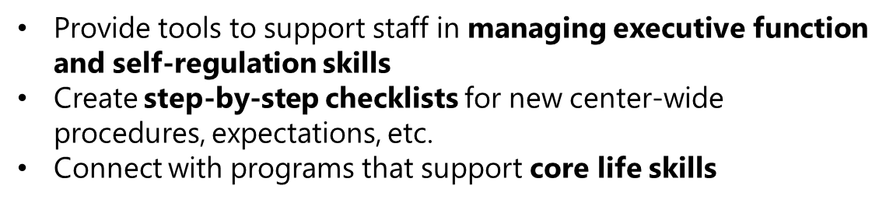

Reflection
Trauma-Informed Teaching in ECE: Part 3

As a leader, how can you apply the three previous principles to support your staff in managing hardship?

Recognizing Common Symptoms of Stress
Trauma-Informed Teaching in ECE: Part 3

If you or your staff (or your families) are exhibiting some of the symptoms below, it may be an indicator of unhealthy levels of stress:
- Feeling irritation, anger, or in denial
- Feeling uncertain, nervous, or anxious
- Lacking motivation
- Feeling tired, overwhelmed, or burned out
- Feeling sad or depressed
- Having trouble sleeping
- Having trouble concentrating
- Physical reactions, such as headaches, body pains, stomach problems, and skin rashes
- Changes in appetite, energy, and activity levels

Concrete Support Strategies:
Social | Emotional
- Cultivate and maintain supportive relationships with all staff members  - Plan for safe, socially-distanced, face-to-face time  - Support managing personal and professional needs  - Find ways to stay connected to the community  - Connect staff to resources | - Allow safe places to process emotions  - Air feelings and talk through problems  - Build in time for breaks  - Develop a professional support system  - Support practicing mindfulness across your school or center  - Give your staff (and yourself) grace as you move through this complex time

Planning to Support Your Staff and Yourself
Trauma-Informed Teaching in ECE: Part 3

How can I…. | For myself: | For my staff:
- Reduce sources of stress
- Provide positive experiences (i.e. through responsive relationships)
- Strengthen core life skills
- Support social well-being
- Support emotional well-being

Next Steps
Closing and Reflection

Prior to our next training:
Share content with teachers from at least one of the following sessions:
- Trauma Informed Teaching in ECE (Parts 1, 2, and/or 3)
- Understanding the Development of Social-Emotional Learning
- Building Social-Emotional Skills (Self-Management and Self-Awareness, and/or Social Awareness or Relationship Skills).
Bring exit tickets or other artifacts of your teacher’s learning to our next session!

