Nevada SEL Series
Session 4

Personal Check-In
Opening and Reflection

Spend the next several minutes silently journaling in response to the questions below:
- Where am I emotionally today? What is fueling those emotions? How is my body physically responding to those emotions? (Pro tip: Check in with, but don’t dive into, your emotions. As you’re looking at yourself and assessing how you feel, back up a little. Consciously ‘look at’ your feelings as if you were viewing them from the outside. The goal is to acknowledge your emotions. Allow them to inform you, not overwhelm you.)

- What do I most need from my colleagues today, to successfully engage in the work ahead of me?

- What do I need to do to take care of myself today, so I can successfully engage in the work ahead of me?

Do Now
Building Social-Emotional Skills

The SEL ABCs
Take a few minutes to brainstorm as many social-emotional skills as you can, trying to come up for one skill for each letter of the alphabet.
For example:
A: Awareness of emotions
B: Building confidence
C: Comforting others

A
B
C
D
E
F
G
H
I
J
K
L
M
N
O
P
Q
R
S
T
U
V
W
X
Y
Z

Why Social-Emotional Competencies?
Building Social-Emotional Skills

As you watch the video, take notes on the following questions:

- How does Ronen Habib’s talk incorporate the power and importance of all five SEL competencies?

- What impact could providing our youngest children with the “compass” to navigate life have on their future, lifelong success?

Revisiting the Core Competencies
Building Social-Emotional Skills

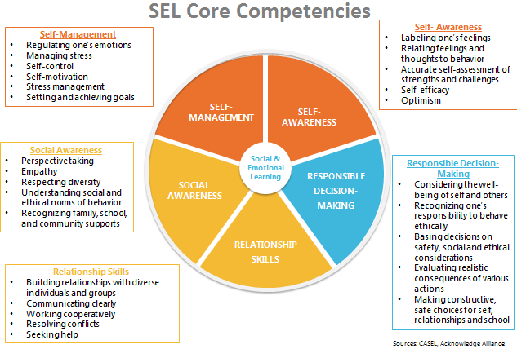

Responsible Decision-Making Skills
Building Social-Emotional Skills

As you watch the video, jot down notes on anything that stands out for you. Look especially for the key features of responsible decision-making skills, and why these skills are important throughout a child’s entire life.

Responsible Decision-Making: The abilities to make caring and constructive choices about personal behavior and social interactions across diverse situations. This includes the capacities to consider ethical standards and safety concerns, and to evaluate the benefits and consequences of various actions for personal, social, and collective well-being.
Responsible Decision-Making includes:
- Demonstrating curiosity and open-mindedness
- Identifying problems and solutions for personal and social problems
- Anticipating and evaluating the consequences of one’s actions
- Reflecting on one’s role to promote well-being

Identifying Responsible Decision-Making Skills
Building Social-Emotional Skills

As you watch the video, take notes on the following:
- Where do you see evidence of responsible decision-making skills in the video?

- What do the children demonstrate?

- How does the teacher reinforce responsible decision-making skills?

Reflection
Building Social-Emotional Skills

What stands out to you most about the teaching and learning of responsible decision-making skills?

Social-Emotional Teaching
Building Social-Emotional Skills

Teachers promote social and emotional learning through a variety of activities and practices, some purposeful and planned, some naturally occurring.

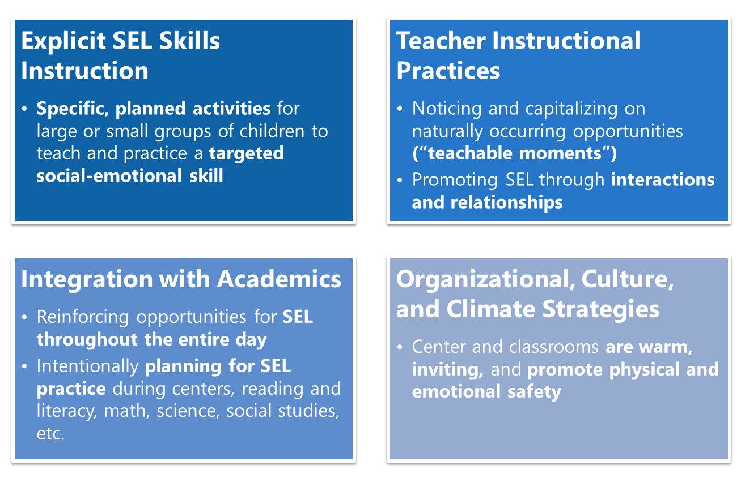

Teacher Instructional Practices
Building Social-Emotional Skills

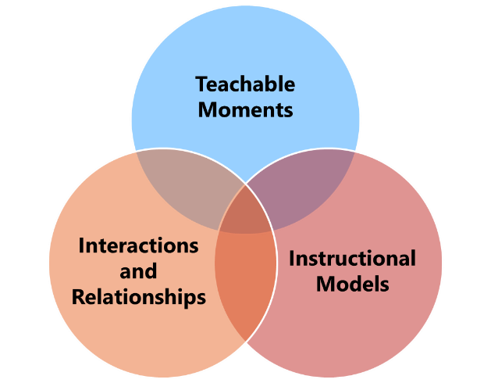

Teacher Instructional Practices refer to three main practices that are developmentally appropriate and culturally responsive: teachable moments, interactions and relationships, and instructional models. These practices provide opportunities for teachers to build social-emotional competencies in an organic, grassroots way in their classrooms.
- Teachable Moments: Noticing an unplanned opportunity that arises in the classroom where a teacher has a chance to offer insight, skills, strategies, and language to children. A teachable moment is not something that can be planned for; rather, it is a fleeting opportunity that must be sensed and seized by the teacher.
- Interactions and Relationships: Intentionally building close relationships with children to be able to leverage those relationships and daily interactions to model, teach, and reinforce social-emotional skills.
- Instructional Models: Utilizing a variety of teaching and engagement strategies to build children’s social-emotional development, particularly through play- and project-based learning.

Teacher Instructional Practices: An Example
Building Social-Emotional Skills

As you watch the video, note:
- What teacher instructional practices does the teacher use to support responsible decision-making skills?

- How do children have a chance to learn and/or practice other SEL skills?

Reflection
Building Social-Emotional Skills

What teacher instructional practices do your teachers already use? How can you support them to strengthen these practices?

What responsible decision-making skills are we most likely to respond to using teacher instructional practices?

Planning for Teacher Instructional Practices
Building Social-Emotional Skills

- PLAN: Independently draft your responses to the provided scenarios below.
- PRACTICE: With your partner, designate a teacher and a student, and role play the scenario of your choice. Each person gets 3 minutes.
- FEEDBACK: Provide one glow and one grow on your partner’s practice, then switch!

Scenario 1: Jada is a preschool teacher at Little Learners Academy. She has carefully prepared a special small-group activity on planting for her students. While the children are planting their seeds, one child, Elias, dumps a whole cup of water into his small plant, causing soil and water to flood the table. How should Jada respond to this teachable moment, especially as an opportunity to reinforce responsible decision-making skills?

Scenario 2: It’s a sunny morning at the beginning of a new week. Alissa has created a fun lesson plan for her read aloud on The Very Hungry Caterpillar, and she’s really excited about it. But when she begins reading the book to the children, they don’t respond as she had hoped. Many children seem distracted and are not engaged with the story. They begin to squirm, and some children start to talk to one another. What can Alissa do in the moment to re-engage children with the story? What instructional models could Alissa employ to engage children further with the content and themes in the story beyond the read aloud?

“What’s Learned Here, Leaves Here”
Building Social-Emotional Skills

What are your biggest take-aways from this session?

What are you most excited to share with your teachers?

How will you carry this learning forward in your own work?

Do Now
Culturally Responsive Teaching in ECE: Part 1

What has been your experience (if any) up to this point with culturally responsive teaching?

How would you define culture?

“Children Grow Into the Intellectual Life Around Them”
Culturally Responsive Teaching in ECE: Part 1

As you watch Zaretta Hammond discuss the foundation of Culturally Responsive Teaching (CRT), take notes on the following questions:
- What are your biggest take-aways from this video?

- What do your teachers do to “set children’s brains on fire” and build academic mindset (chart below)?

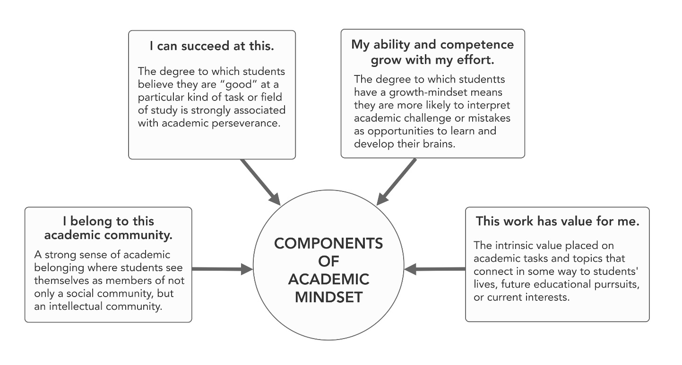
What is Culturally Responsive Teaching?
Culturally Responsive Teaching in ECE: Part 1

Culturally Responsive Teaching (CRT) is “an educator’s ability to recognize students’ cultural displays of learning and meaning-making and respond positively and constructively with teaching moves that use cultural knowledge as a scaffold to connect what the student knows to new concepts and content in order to promote effective information processing. All the while, the educator understands the importance of being in relationship and having a social-emotional connection to the student in order to create a safe space for learning.”
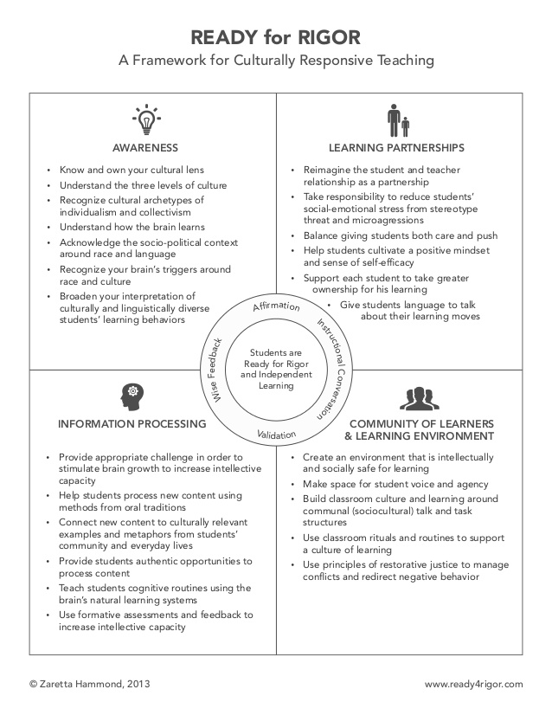
Awareness: Understanding the Roots of Culture
Culturally Responsive Teaching in ECE: Part 1

“Teachers need adequate background knowledge and usable information in order to know how to apply culturally responsive tools and strategies. Building background knowledge begins with becoming knowledgeable about the dimension of culture as well as knowledgeable about the larger social, political, and economic conditions that create inequitable education outcomes.”

Key Definitions:
Culture: the way that every brain makes sense of the world, like software for the brain’s hardware. The brain uses cultural information to turn everyday happenings into meaningful events.
- Surface culture: Observable and concrete elements of culture such as food, dress, music, and holidays. This has a low emotional charge.
- Shallow culture: The unspoken rules around everyday social interactions and norms, such as courtesy, attitudes towards elders, nature of friendship, concepts of time, personal space between people, nonverbal communication, appropriate eye contact and touching, etc. This level has a strong emotional charge—it’s how put into action our deep cultural values.
- Deep culture: The tacit knowledge and unconscious assumptions that govern our worldview. Also contains the cosmology (view of good or bad) that guides ethics, spirituality, health, and theories of group harmony (i.e. competition or cooperation). Also governs how we learn new information. This level has an intense emotional charge—challenges at this level produce culture shock or trigger the brain’s fight or flight response.
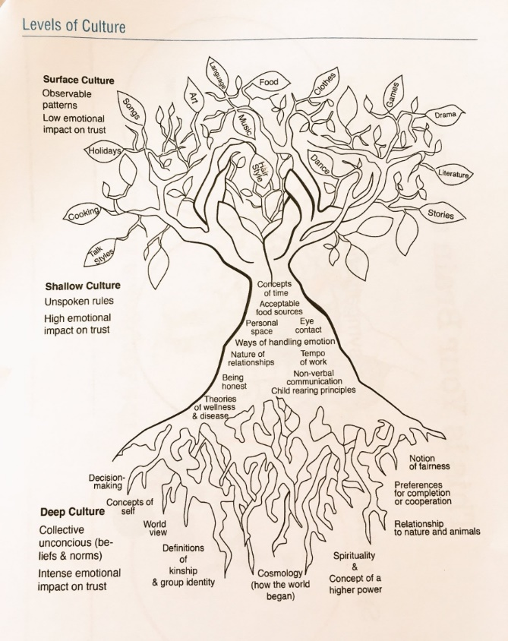
Cultural Archetypes: universal patterns across cultures
- Collectivism: Societies that emphasize relationships, interdependence within a community, and cooperative learning. (dominant culture in many AA, Latino, Pacific Islander, and Indigenous communities). How collectivism is expressed varies, but focus on relationships and cooperative learning stays the same.
- Individualism: Societies that emphasize individual achievement and independence. (dominant culture in America)
- Oral tradition: Recording and sustaining cultures and cultural identities by word of mouth; telling stories and coding knowledge into songs, chants, proverbs, and poetry. Makes the most of the brain’s memory systems by using alliteration, movement, and emotion as strong cognitive anchors.
- Written tradition: Does not require much person-to-person interaction or dialogue because thoughts are committed to print.
Sociopolitical Context: The series of mutually reinforcing policies and practices across social, economic, and political domains that contribute to disparities for people of color in housing, transportation, education, and health care, to name a few. Unequal opportunities resulting in unequal outcomes along race and class lines.
- Implicit Bias: The unconscious attitudes and stereotypes that shape our responses to certain groups. Operates involuntarily, often without one’s awareness or intentional control.
- Structural Racialization: The factors within society’s systems (housing, education, healthcare, etc.) that interact to create and perpetuate social, economic, and political structures that are harmful to people of color and to our society as a whole.

Sociopolitical Context vs. the “Culture” of Poverty
Culturally Responsive Teaching in ECE: Part 1

“There’s considerable research that clearly states that people in poverty are not, in fact, lazier, less likely to value education, or more likely to be substance abusers than their wealthier counterparts. Yet, implicit racial bias reinforces the notion of people of color willingly living in poverty or unmotivated to charge their circumstances. This view ignores the contributing factors of structural racialization in society that limit a family’s economic and educational opportunities.”
- Poverty is NOT a culture: Poverty is a condition or symptom of the structural inequities built into our social and economic systems. Poverty for most families is not a lifestyle choice. Poverty doesn’t fit the definition of culture in that it doesn’t have deep cultural roots governed by a cosmology or worldview.

- Coping skills are mistaken for norms and beliefs: What appears to be a “culture”—norms, beliefs, and behaviors that are transmitted from one generation to another—are more accurately coping and survival mechanisms that help marginalized communities navigate racial and economic caste systems; due to the often generational nature of poverty, these coping mechanisms become codified and misconstrued as “culture”.

- Poor people do not normalize or glorify negative aspects of living in poverty: Despite images we commonly see in popular media, negative aspects of living in poverty (drug use, violence, etc.) are not normalized and embraces as lifestyle choices by poor people. Often, those behaviors are an outgrowth of post-traumatic stress disorder (PTSD). As many as one-third of children living in our country’s urban neighborhoods have PTSD—nearly twice that reported for troops returning from war zones in Iraq. (Stanford’s Early Life Stress Research Program, 2007.)

Reflection
Culturally Responsive Teaching in ECE: Part 1

Which levels of your children’s culture do you know the most about? Which do you know the least about?

Brainstorm
Culturally Responsive Teaching in ECE: Part 1

What are the different ways we could operationalize the different levels of culture in our centers and classrooms? (Reference back to the Culture Tree for examples of surface, shallow, and deep culture.)
Surface Culture | Shallow Culture | Deep Culture

Next Steps
Closing and Reflection

Prior to our next training:
Share content with teachers (virtually or in-person) from at least one of the following sessions:
- Trauma Informed Teaching in ECE (Parts 1, 2, and/or 3)
- Understanding the Development of Social-Emotional Learning
- Building Social-Emotional Skills (Self-Management and Self-Awareness, Social Awareness and Relationship Skills, and/or Responsible Decision-Making Skills).
- Culturally Responsive Teaching in ECE: Part 1
Make sure to collect exit tickets/feedback from your teachers to bring to share during Session 5

