Nevada SEL Series
Session 5

Personal Check-In
Opening and Reflection

Spend the next several minutes silently journaling in response to the questions below:
- Where am I emotionally today? What is fueling those emotions? How is my body physically responding to those emotions? (Pro tip: Check in with, but don’t dive into, your emotions. As you’re looking at yourself and assessing how you feel, back up a little. Consciously ‘look at’ your feelings as if you were viewing them from the outside. The goal is to acknowledge your emotions. Allow them to inform you, not overwhelm you.)

- What do I most need from my colleagues today, to successfully engage in the work ahead of me?

- What do I need to do to take care of myself today, so I can successfully engage in the work ahead of me?

Do Now
Integrating SEL Throughout the Day

Take a few minutes to list all the ways that social-emotional learning is practiced (intentionally or unintentionally) throughout the day in your center(s) or school(s).

Revisiting the Core Competencies
Integrating SEL Throughout the Day

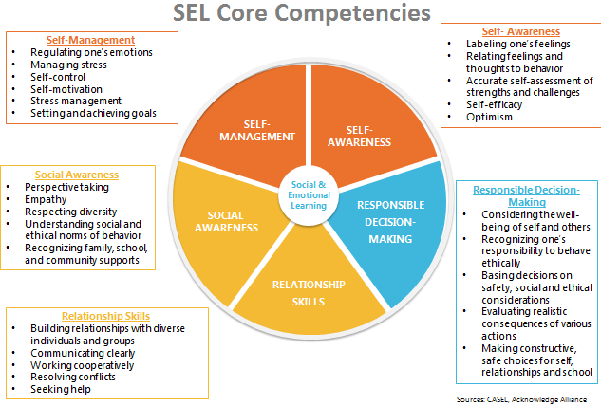

Evidence of Social-Emotional Learning
Integrating SEL Throughout the Day

As you watch the video, take notes on the following question:
Where do you see evidence of children practicing social-emotional skills?
Notes: | Aligned Competency/Competencies

Social-Emotional Teaching
Integrating SEL Throughout the Day

Teachers promote social and emotional learning through a variety of activities and practices, some purposeful and planned, some naturally occurring.

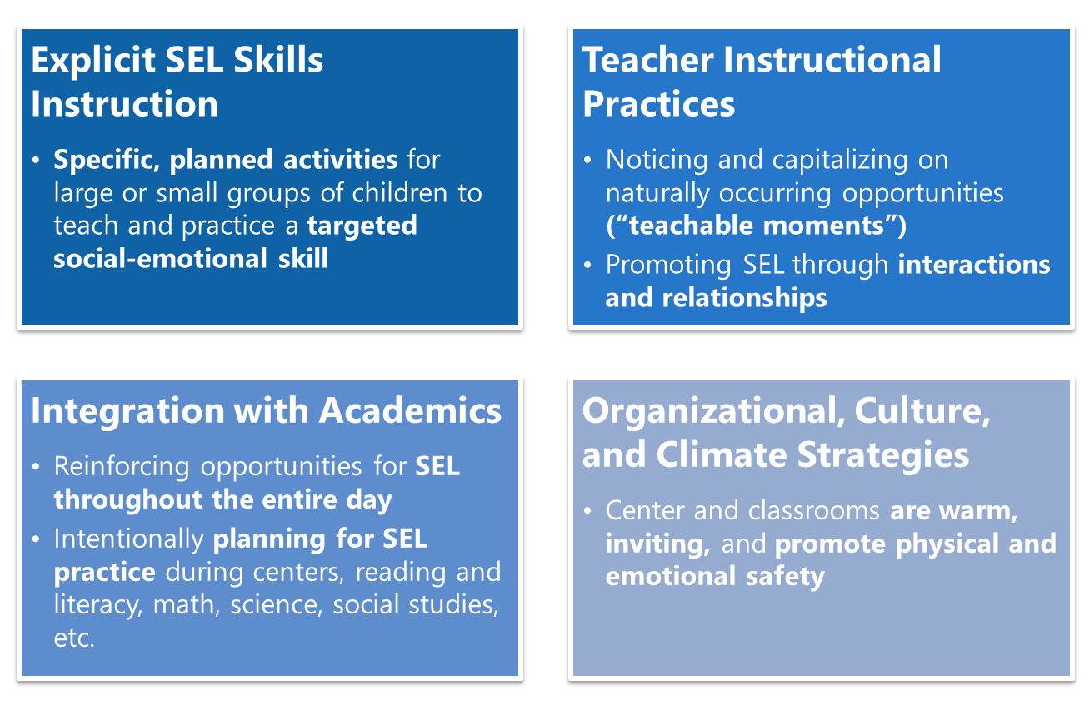

Integration with Academics
Integrating SEL Throughout the Day

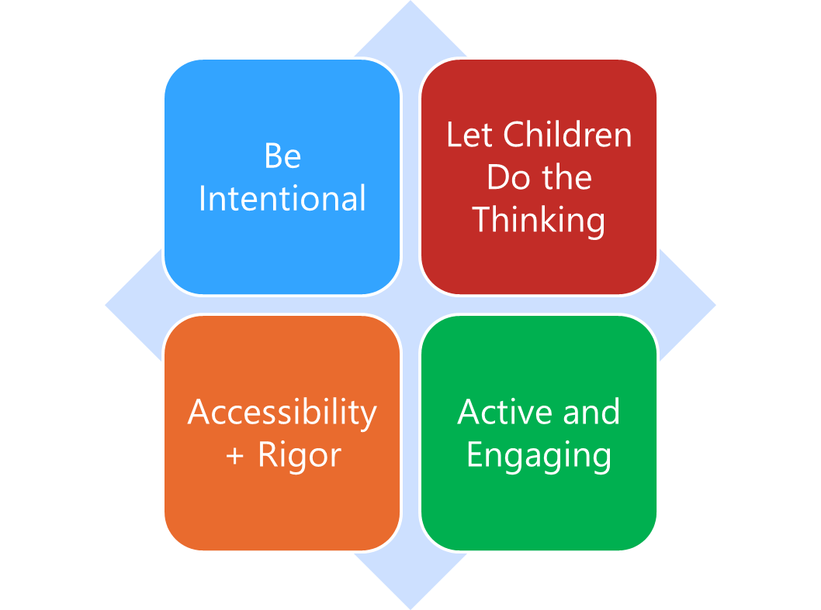

Integration with Academics refers to the essential practice of teaching children academic content and social-emotional skills in an intentionally interwoven way throughout the day. Teachers know the importance of teaching the whole child, and that no learning happens in a vacuum. The more we intentionally integrate SEL opportunities thoughtfully within other learning opportunities during the day, the better practice children will get across all their skills.
- Be intentional: Social and emotional skills come up all the time — at recess, in group work, in center time, during morning meeting, in small group lessons, etc. Be intentional about identifying opportunities to practice the skills with children, and build targeted skills into plans to best maximize those opportunities. Social-emotional learning opportunities are already going to be there in everything our children are doing and learning—it’s up to teachers to name those skills for children, and purposefully build opportunities for children to learn social-emotional skills while also engaging in learning across other domains.
- Let Children Do the Thinking: When integrating SEL with other content areas and parts of the day, make sure the majority of learning opportunities give children the chance to practice and engage with social-emotional skills. Teachers should still model, role play, provide language, etc. as necessary, but don’t over-intervene; give children chances to practice, make mistakes, self-correct, and problem solve!
- Accessibility+Rigor: Make sure learning opportunities are always accessible to children in developmentally-appropriate ways, but also challenge children to grow, try, and learn new things—in more academic areas and in social-emotional skill development! This could mean having choice for how to engage in particular activities, how much teacher support is provided during different learning times, etc.
- Active and Engaging: As with all learning in our early childhood classroom, the learning of content and social-emotional skills should be hands-on, active, and fun!

Remember: “SEL isn’t one more thing on the plate—it IS the plate.”

Integrating SEL and Academics: An Example
Integrating SEL Skills Throughout the Day

Clip 1:
Where do you notice the principles of integration with academics in this quick video?
Be Intentional
Let Children Do the Thinking
Accessibility + Rigor
Active and Engaging

Clip 2:
As you watch the video, take notes on where you specifically see the integration of academic learning and exploration with the building of social-emotional skills.

Reflection
Integrating SEL Throughout the Day

How are your teachers already integrating SEL within academics? How can you support them to strengthen these practices?

What opportunities to integrate SEL with academics exist over the course of a typical day in your center(s) or school(s)?

Planning to Integrate SEL and Academics
Integrating SEL Throughout the Day

Think of one of the classrooms in your center(s) or school(s), and independently brainstorm:
- In that classroom, what are the biggest opportunities to intentionally integrate SEL with academics?
- How could teachers in that classroom incorporate SEL more intentionally into other learning?
- Which SEL competencies would children be practicing?

Time of Day (centers, read aloud, small groups, independent play, etc.) | How to intentionally integrate SEL with other learning? | Which SEL competencies most align?

“What’s Learned Here, Leaves Here”
Integrating SEL Throughout the Day

What are your biggest take-aways from this session?

What are you most excited to share with your teachers?

How will you carry this learning forward in your own work?

Do Now
Culturally Responsive Teaching in ECE: Part 2

Recall an important teacher in your own life. How would you describe the relationship? What made it feel like a partnership?

How do you build relationships across difference?

Start with Responsive
Culturally Responsive Teaching in ECE: Part 2

As you listen to the “blogcast”, respond to the following questions:
- What is the “true starting point” for culturally responsive teaching?

- What are your major takeaways from this brief blogcast?

What is Culturally Responsive Teaching?
Culturally Responsive Teaching in ECE: Part 2

Culturally Responsive Teaching (CRT) is “an educator’s ability to recognize students’ cultural displays of learning and meaning-making and respond positively and constructively with teaching moves that use cultural knowledge as a scaffold to connect what the student knows to new concepts and content in order to promote effective information processing. All the while, the educator understands the importance of being in relationship and having a social-emotional connection to the student in order to create a safe space for learning.”
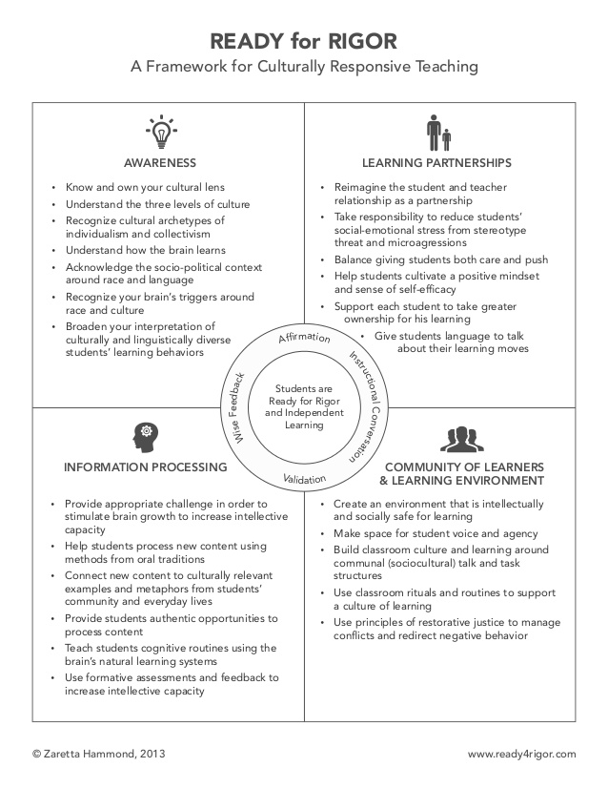
Trust Generators
Culturally Responsive Teaching in ECE: Part 2

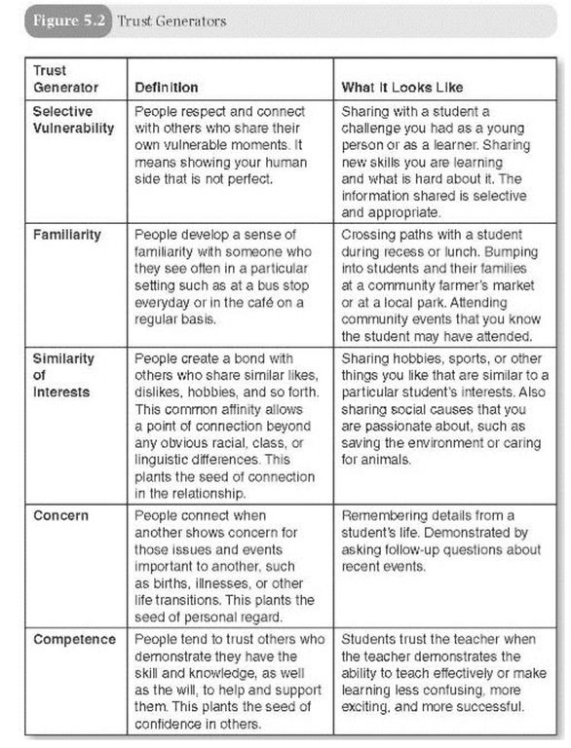
Reflection
Culturally Responsive Teaching in ECE: Part 2

How do you create a sense of trust and rapport in your relationships with children?

What do you do deliberately? What do you do randomly?

My Points of Connection
Culturally Responsive Teaching in ECE: Part 2

Use the worksheet below to reflect on how you might use the trust generators to build more authentic connections with your children.
My Points of Connection
- What do you see as the best points of connection you can make with your children?

In the space on the right, identify a few experiences or stories you might share based on some combination of the trust generators.
Trust Generators:
- Selective Vulnerability
- Familiarity
- Similarity & Interests
- Concern
- Competence

“What’s Learned Here, Leaves Here”
Culturally Responsive Teaching in ECE: Part 2

What are your biggest take-aways from this session?

What are you most excited to share with your teachers?

How will you carry this learning forward in your own work?

Next Steps
Closing and Reflection

Prior to our next training:
Our next and final training will be Thursday, April 8th from 9 AM-1 PM PST.
Share content with teachers (virtually or in-person) from any of the sessions we’ve engaged in so far. Make sure to collect exit tickets/feedback from your teachers to bring to share during Session 6.

