Nevada SEL Series
Session 6

Personal Check-In
Opening and Reflection

Spend the next several minutes silently journaling in response to the questions below:
- Where am I emotionally today? What is fueling those emotions? How is my body physically responding to those emotions? (Pro tip: Check in with, but don’t dive into, your emotions. As you’re looking at yourself and assessing how you feel, back up a little. Consciously ‘look at’ your feelings as if you were viewing them from the outside. The goal is to acknowledge your emotions. Allow them to inform you, not overwhelm you.)

- What do I most need from my colleagues today, to successfully engage in the work ahead of me?

- What do I need to do to take care of myself today, so I can successfully engage in the work ahead of me?

Do Now
Integrating SEL Into Center/School Culture

Imagine there is a new family starting at your center today.

- When they walk into your center for the first time, what do you want them to FEEL from your center or school’s culture? From the culture in their child’s classroom?

- What do you want them to SEE that represents your center or school’s culture? Their child’s classroom culture?

Revisiting the Core Competencies
Integrating SEL Into Center/School Culture

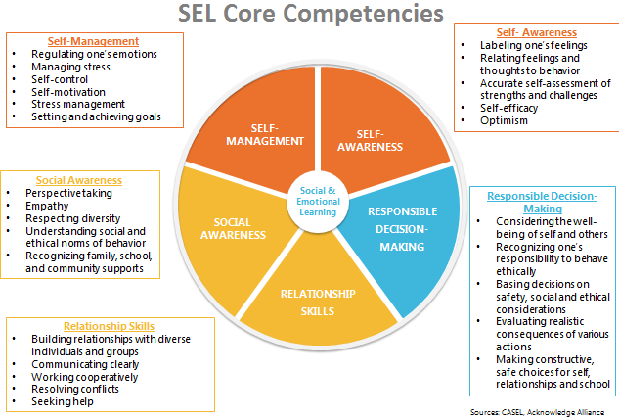

Social-Emotional Teaching
Integrating SEL Into Center/School Culture

Teachers promote social and emotional learning through a variety of activities and practices, some purposeful and planned, some naturally occurring.

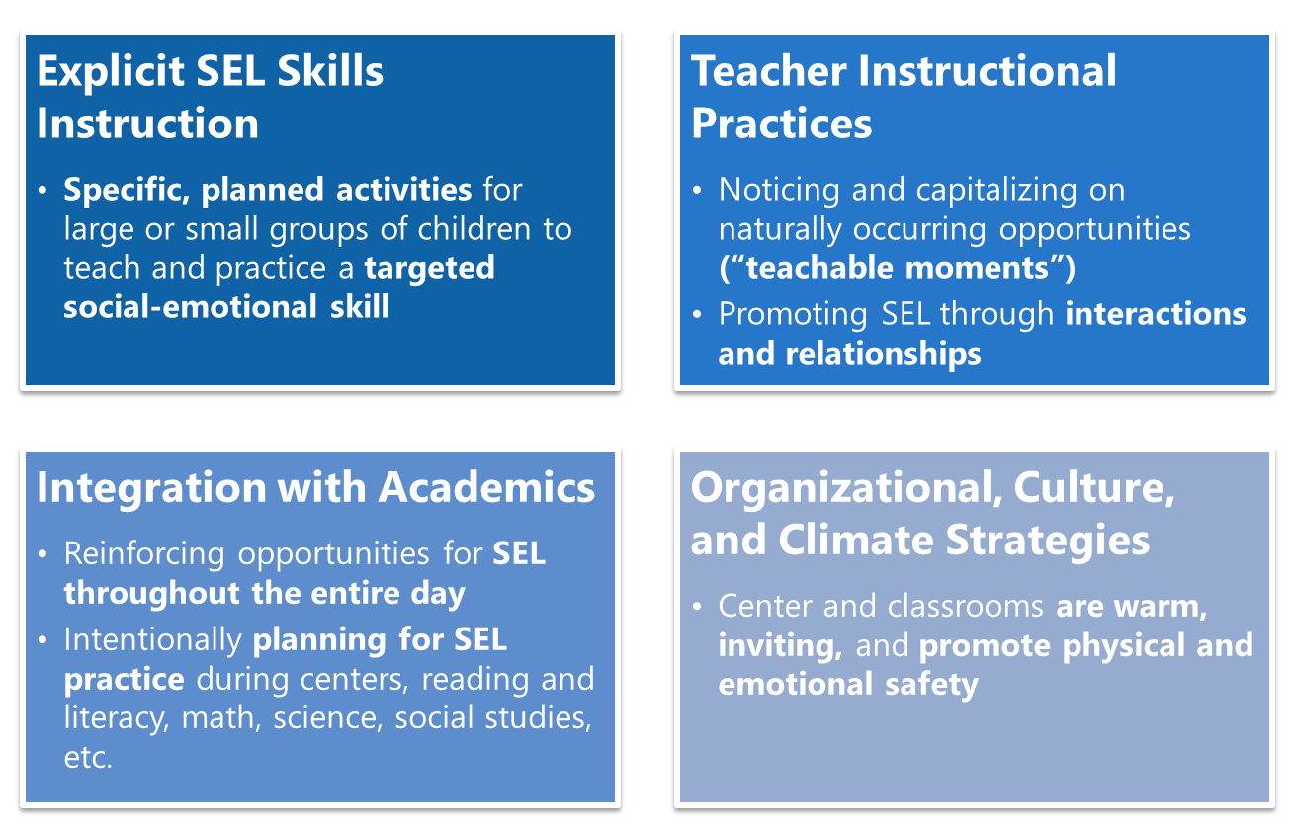

What Shapes Classroom and Center Culture?
Integrating SEL Into Center/School Culture

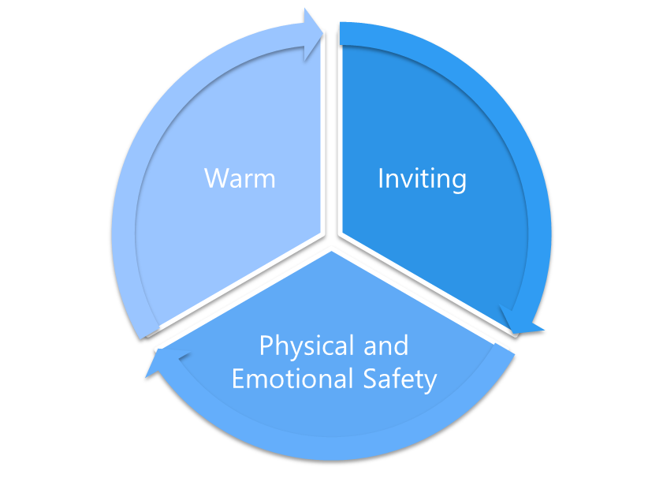

What makes a classroom or school/center culture warm, inviting, and physically and emotionally safe?

Remember: “SEL isn’t one more thing on the plate—it IS the plate.”

Designing for Culture and Climate: An Example
Integrating SEL Into Center/School Culture

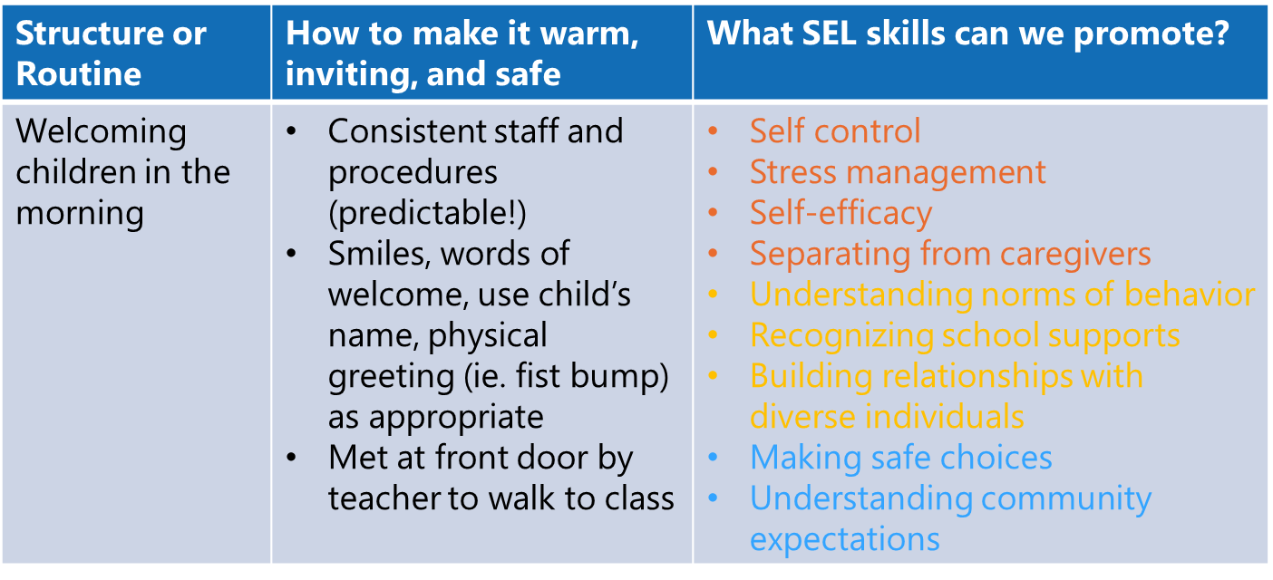
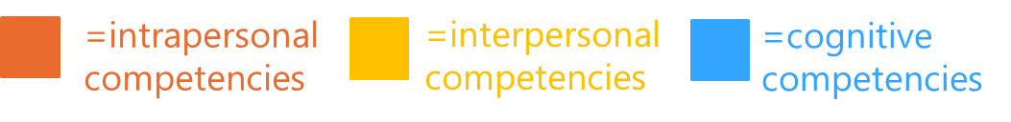
Notes from think aloud:

Designing for Culture and Climate: Practice
Integrating SEL Into Center/School Culture

Structure or Routine | How to make it warm, inviting, and safe | What SEL skills can we promote?

Reflection
Integrating SEL Into Center/School Culture

What are the biggest opportunities in your center or school to increase social-emotional learning through center-wide culture and climate?

Culture and Climate Strategies: Example
Integrating SEL Into Center/School Culture

As you watch the video, take notes on the following questions:
- How does this video demonstrate a culture that is warm, inviting, and promotes physical and emotional safety?

- What social-emotional skills are children practicing? What are teachers modeling?

Designing for Culture and Climate: Practice
Integrating SEL Into Center/School Culture

Structure or Routine | How to make it warm, inviting, and safe | What SEL skills can we promote?

Reflection
Integrating SEL Into Center/School Culture

How might planning in this way support social-emotional learning across the classrooms in your center?

Carrying SEL Forward
Integrating SEL Into Center/School Culture

Social-Emotional Teaching Best Practice | Center Goal(s) | Classroom Goal(s)

Explicit SEL Skills Instruction

Teacher Instructional Practice

Integration with Academics

Organizational, Culture, and Climate Strategies

Do Now
Observing for Social-Emotional Development

Take a few minutes to respond to the questions below:

- When you are observing a teacher’s classroom, what do you look for to help you determine their efficacy?

- Given what you’ve shared with your teachers from this course, what practices do you expect to see in their classrooms?

Reflection
Observing for Social-Emotional Development

How will the SEL rubric support you and your teachers in growing social-emotional learning opportunities for children across your center or school?

Collecting Good Data in the Classroom
Observing for Social-Emotional Development

Take notes on the criteria below.
Criteria for Effective Note-Taking:
- Know the rubric:

- Find a good vantage point(s):

- Use shorthand:

- Notice teacher and student actions:

- Write low-inference notes:

Effective Low-Inference Notes
Observing for Social-Emotional Development

Low-Inference Note-Taking: Describe what is taking place without drawing conclusions or making judgments about what you observe.
Your notes should:
- Be objective and focus specifically on what is happening. Stay away from notes that say “I think” or “I feel”.

- Notes capture specific evidence. For example, instead of “many children raised their hands” say “8 of 10 children raised their hands.

- Contain actual teacher and child quotes. For example, instead of “teacher asked open-ended questions”, write the actual questions that teachers used.

- Be void of emotion or judgment. For example, saying something like “the environment is beautiful” implies judgment, and something like “teacher effectively engaged children” is subjective.

Revising Non-Exemplar Notes
Observing for Social-Emotional Development

Non-Exemplar Sample Notes:
1:00 Children on carpet during explicit SEL mini-lesson. Lots of children walking around the classroom while the teacher tried to get their attention.
1:01 Teacher asked questions about a large displayed picture card. Many children were not looking at the card.
1:02 1 child called out over and over again when you asked the question about what was happening in the picture. Lesson is falling apart and unsuccessful.
Revised Notes:

How to Rate on the SEL Rubric
Observing for Social-Emotional Development

How to rate overall performance on the SEL Rubric:
- Decide on your rating for each indicator.

- Consider the ratings for all the indicators under a particular competency (i.e. Social-Emotional Teaching).

- Using your evidence and indicator ratings, assign an overall rating to that competency: Novice, Approaching Developing, Developing, Proficient.

- Write 2-3 evidence statements that support your overall rating.

- Repeat for each relevant competency.

Practice: Observing for Social-Emotional Development
Observing for Social-Emotional Development

As we watch this video of a toddler classroom, use what you know about effective note-taking to collect data aligned to the SEL rubric.

Video Notes:

Rate the Teacher’s Performance
Observing for Social-Emotional Development

Focus on the first domain of the SEL Observation Tool (Social-Emotional Teaching) and follow the steps below:
- Decide on your rating for each indicator.
- Consider the ratings for all the indicators under a particular competency (i.e. Social-Emotional Teaching).
- Using your evidence and indicator ratings, assign an overall rating to that competency: Novice, Approaching Developing, Developing, Proficient.
Considering how you just rated this teacher across the rubric:
- What are the 1-2 biggest strengths you noticed in this teacher’s classroom as related specifically to the SEL rubric?

- What is the one thing, that if improved, would have the biggest impact on social-emotional learning in this teacher’s classroom?

Remember to ground your thinking in the specific indicators and language of the rubric! Be prepared to share in small groups.

Closing Reflection
Observing for Social-Emotional Development

- What was easiest about using the SEL rubric to rate teacher performance? What was most difficult?

- How will you use this rubric, in conjunction with other rubrics, to ensure SEL is being integrated across the day in your classrooms?

