Do Now
Building Social-Emotional Skills

The SEL ABCs
Take a few minutes to brainstorm as many social-emotional skills as you can, trying to come up for one skill for each letter of the alphabet.
For example:
A: Awareness of emotions
B: Building confidence
C: Comforting others

A
B
C
D
E
F
G
H
I
J
K
L
M
N
O
P
Q
R
S
T
U
V
W
X
Y
Z

Why Social-Emotional Competencies?
Building Social-Emotional Skills

As you watch the video, take notes on the following questions:

- How does Ronen Habib’s talk incorporate the power and importance of all five SEL competencies?

- What impact could providing our youngest children with the “compass” to navigate life have on their future, lifelong success?

Revisiting the Core Competencies
Building Social-Emotional Skills

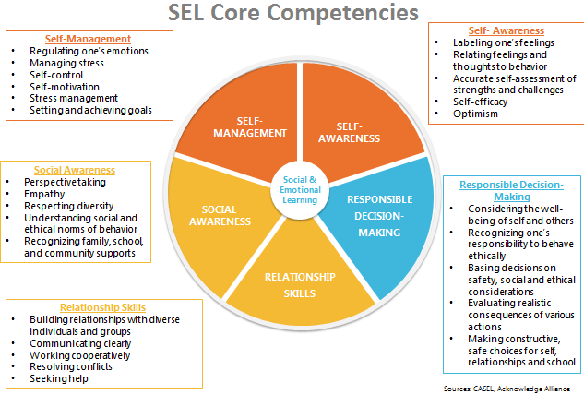

Responsible Decision-Making Skills
Building Social-Emotional Skills

As you watch the video, jot down notes on anything that stands out for you. Look especially for the key features of responsible decision-making skills, and why these skills are important throughout a child’s entire life.

Responsible Decision-Making: The abilities to make caring and constructive choices about personal behavior and social interactions across diverse situations. This includes the capacities to consider ethical standards and safety concerns, and to evaluate the benefits and consequences of various actions for personal, social, and collective well-being.
Responsible Decision-Making includes:
- Demonstrating curiosity and open-mindedness
- Identifying problems and solutions for personal and social problems
- Anticipating and evaluating the consequences of one’s actions
- Reflecting on one’s role to promote well-being

Identifying Responsible Decision-Making Skills
Building Social-Emotional Skills

As you watch the video, take notes on the following:
- Where do you see evidence of responsible decision-making skills in the video?

- What do the children demonstrate?

- How does the teacher reinforce responsible decision-making skills?

Reflection
Building Social-Emotional Skills

What stands out to you most about the teaching and learning of responsible decision-making skills?

Social-Emotional Teaching
Building Social-Emotional Skills

Teachers promote social and emotional learning through a variety of activities and practices, some purposeful and planned, some naturally occurring.

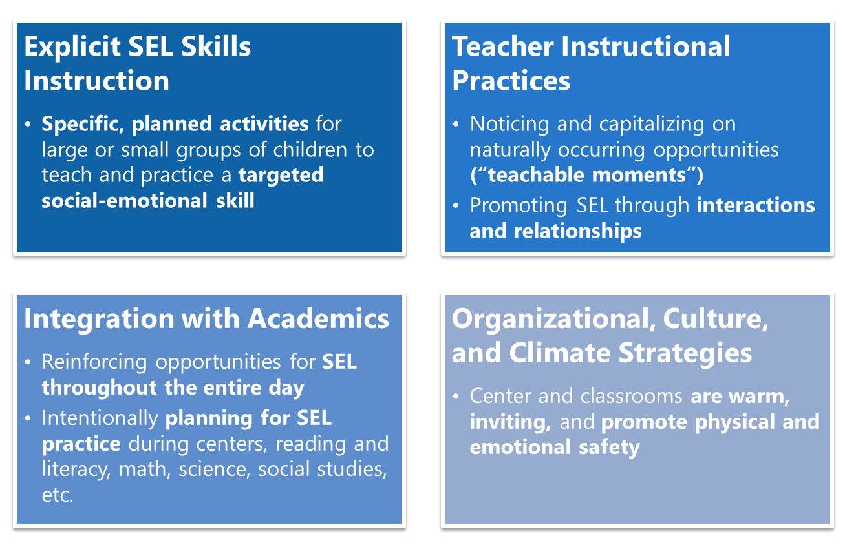

Teacher Instructional Practices
Building Social-Emotional Skills

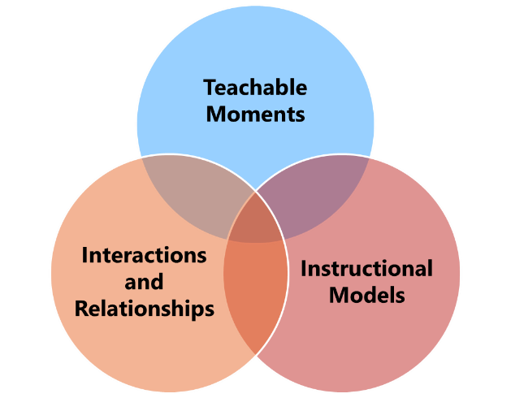

Teacher Instructional Practices refer to three main practices that are developmentally appropriate and culturally responsive: teachable moments, interactions and relationships, and instructional models. These practices provide opportunities for teachers to build social-emotional competencies in an organic, grassroots way in their classrooms.
- Teachable Moments: Noticing an unplanned opportunity that arises in the classroom where a teacher has a chance to offer insight, skills, strategies, and language to children. A teachable moment is not something that can be planned for; rather, it is a fleeting opportunity that must be sensed and seized by the teacher.
- Interactions and Relationships: Intentionally building close relationships with children to be able to leverage those relationships and daily interactions to model, teach, and reinforce social-emotional skills.
- Instructional Models: Utilizing a variety of teaching and engagement strategies to build children’s social-emotional development, particularly through play- and project-based learning.

Teacher Instructional Practices: An Example
Building Social-Emotional Skills

As you watch the video, note:
- What teacher instructional practices does the teacher use to support responsible decision-making skills?

- How do children have a chance to learn and/or practice other SEL skills?

Reflection
Building Social-Emotional Skills

What teacher instructional practices do you already use? Which do you want to strengthen?

Planning for Teacher Instructional Practices
Building Social-Emotional Skills

- PLAN: Independently draft your responses to the provided scenarios below.
- PRACTICE: With your partner, designate a teacher and a student, and role play the scenario of your choice. Each person gets 3 minutes.
- FEEDBACK: Provide one glow and one grow on your partner’s practice, then switch!

Scenario 1: Jada is a preschool teacher at Little Learners Academy. She has carefully prepared a special small-group activity on planting for her students. While the children are planting their seeds, one child, Elias, dumps a whole cup of water into his small plant, causing soil and water to flood the table. How should Jada respond to this teachable moment, especially as an opportunity to reinforce responsible decision-making skills?

Scenario 2: It’s a sunny morning at the beginning of a new week. Alissa has created a fun lesson plan for her read aloud on The Very Hungry Caterpillar, and she’s really excited about it. But when she begins reading the book to the children, they don’t respond as she had hoped. Many children seem distracted and are not engaged with the story. They begin to squirm, and some children start to talk to one another. What can Alissa do in the moment to re-engage children with the story? What instructional models could Alissa employ to engage children further with the content and themes in the story beyond the read aloud?

“What’s Learned Here, Leaves Here”
Building Social-Emotional Skills

What are your biggest take-aways from this session?

How will you carry this learning forward in your own work?

