Do Now
Building Social-Emotional Skills

In our opening session, you were asked to do some independent reflection, small group sharing, and whole group sharing. Think closely about what you needed to be able to do to be successful in those activities, then respond to the questions below:
- What self-awareness skills did you need to engage successfully in our opening session?

- What self-management skills did you need to engage successfully in our opening session?

Setting the Stage
Building Social-Emotional Skills

As you watch the TedTalk from Dr. Rosemarie Allen, take notes on the following:
- How are adults responsible for the teaching and modeling of self-awareness and self-management skills?

- How do (or should) adults rely on their own social-emotional skills to support children?

- Why is it essential to teach instead of punish?

Revisiting the Core Competencies
Building Social-Emotional Skills

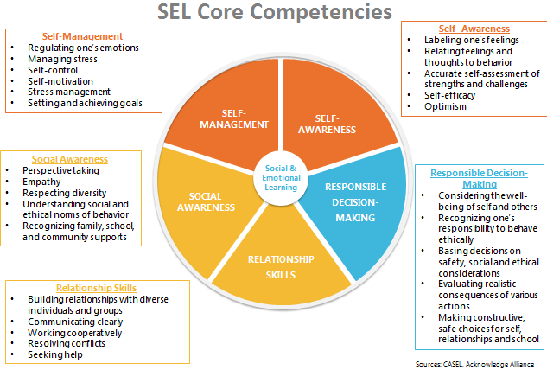

Self-Awareness
Building Social-Emotional Skills

As you watch the video, jot down notes on anything that stands out for you. Look especially for the key features of self-awareness, and why self-awareness skills are important throughout a child’s entire life.

Self-Awareness: The ability to accurately recognize one’s own emotions, thoughts, and values and how they influence behavior across contexts. The ability to accurately assess one’s strengths and limitations, with a well-grounded sense of confidence, optimism, and a “growth mindset.”
Self-Awareness includes:
- Identifying emotions
- Accurate self-perception
- Recognizing strengths
- Self-confidence
- Self-efficacy
- Identifying personal, cultural, and linguistic assets
- Linking feelings, values, and thoughts
- Having a growth mindset
- Developing interests and a sense of purpose

Self-Management
Building Social-Emotional Skills

As you watch the video, jot down notes on anything that stands out for you. Look especially for the key features of self-management, and why self-management skills are important throughout a child’s entire life.

Self-Management: The ability to successfully regulate one’s emotions, thoughts, and behaviors in different situations — effectively managing stress, controlling impulses, and motivating oneself. The ability to set and work toward personal and academic goals.
Self-Management includes:
- Impulse control
- Stress management
- Organizational skills
- Managing one’s emotions
- Identifying and using stress management strategies
- Exhibiting self-discipline and self-motivation
- Setting personal and collective goals
- Showing the courage to take initiative

Identifying Self-Awareness and Self-Management
Building Social-Emotional Skills

Clip 1: Young Toddlers
As you watch the video, take notes on the following:
- Where do you see evidence of self-management and self-awareness in the video?

- What do the children demonstrate? How does the teacher reinforce these skills?

Clip 2: Preschool
As you watch the video, take notes on the following:
- Where do you see evidence of self-management and self-awareness in the video?

- What do the children demonstrate? How does the teacher reinforce these skills?

Reflection
Building Social-Emotional Skills

What stands out to you most about the teaching and learning of self-awareness and self-management skills?

Social-Emotional Teaching
Building Social-Emotional Skills

Teachers promote social and emotional learning through a variety of activities and practices, some purposeful and planned, some naturally occurring.

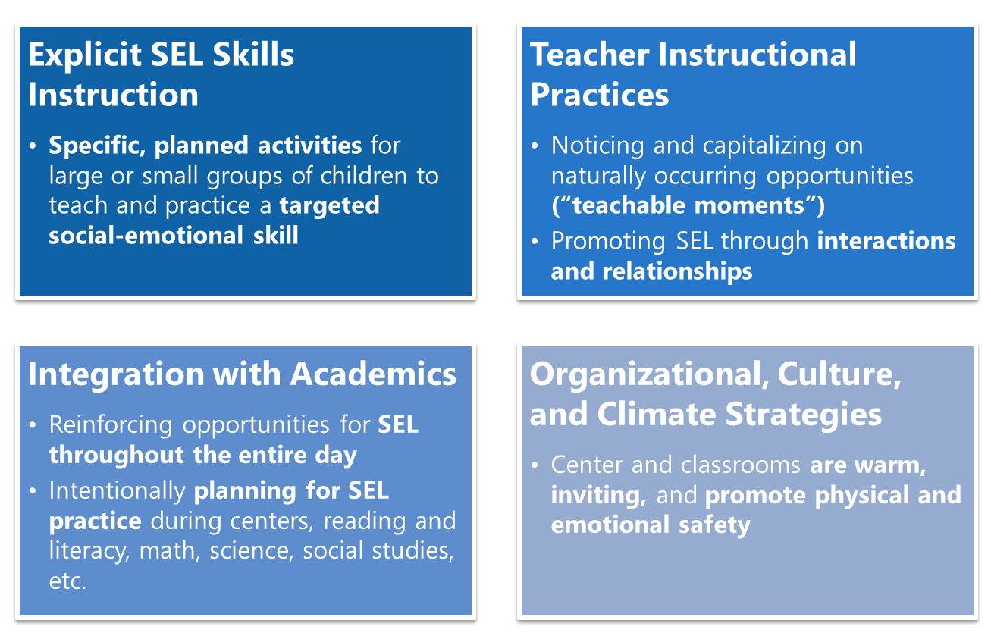

Putting the Pieces Together
Building Social-Emotional Skills

Consider each social-emotional teaching strategy through the lens of teaching self-awareness and self-management. What would you do to effectively teach self-awareness and self-management using each teaching strategy?
Explict sel skills instruction | teacher instructional practices
integration with academics | organizational, culture, & climate strategies

Reflection
Building Social-Emotional Skills

Respond to the following questions below.
What SEL teaching strategies do you already use reliably?

What strategies will you need to be more intentional in implementing?

“What’s Learned Here, Leaves Here”
Building Social-Emotional Skills

What are your biggest take-aways from this session?

How will you carry this learning forward in your own work?

