Do Now
Building Social-Emotional Skills

In today’s session, we’ll be diving into interpersonal competencies: social awareness and relationship skills.
- What do children (and adults!) need to know to successfully engage in social interactions and build relationships?

- What do children (and adults!) need to be able to do to successfully engage in social interactions and build relationship?

Revisiting the Core Competencies
Building Social-Emotional Skills

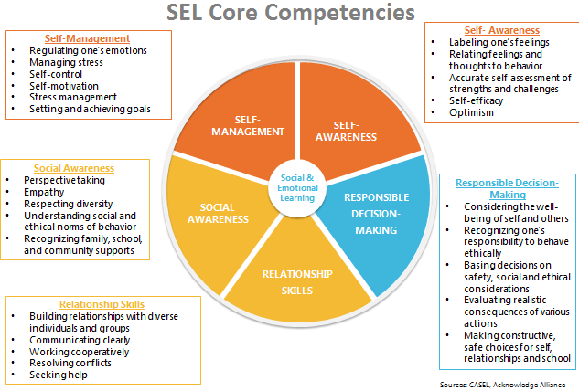

Social Awareness
Building Social-Emotional Skills

As you watch the video, jot down notes on anything that stands out for you. Look especially for the key features of social awareness, and why social awareness skills are important throughout a child’s entire life.

Social Awareness: The abilities to take the perspective of and empathize with others, including those from diverse backgrounds, cultures, and contexts. This includes the capacities to feel compassion for others, understand broader historical and social norms for behavior in different settings, and recognize family, school, and community resources and supports.
Social Awareness includes:
- Demonstrating empathy and compassion
- Appreciating diversity
- Respect for others
- Taking others’ perspectives
- Recognizing strengths in others
- Showing concern for the feelings of others
- Understanding and expressing gratitude

Relationship Skills
Building Social-Emotional Skills

As you watch the video, jot down notes on anything that stands out for you. Look especially for the key features of relationship skills, and why relationship skills are important throughout a child’s entire life.

Relationship Skills: The abilities to establish and maintain healthy and supportive relationships and to effectively navigate settings with diverse individuals and groups. This includes the capacities to communicate clearly, listen actively, cooperate, work collaboratively to problem solve and negotiate conflict constructively, navigate settings with differing social and cultural demands and opportunities, provide leadership, and seek or offer help when needed.
Relationship Skills include:
- Social engagement

- Communicating effectively

- Developing positive relationships

- Practicing teamwork and collaborative problem-solving

- Resolving conflicts constructively

- Seeking or offering support and help when needed

Identifying Social Awareness and Relationship Skills
Building Social-Emotional Skills

Clip 1: Toddlers
As you watch the video, take notes on the following:
- Where do you see evidence of social awareness and relationship skills in the video?

Clip 2: Preschool
As you watch the video, take notes on the following:
- Where do you see evidence of social awareness and relationship skills in the video?

- How does the teacher reinforce these skills?

Reflection
Building Social-Emotional Skills

What stands out to you most about the teaching and learning of social awareness and relationship skills?

Social-Emotional Teaching
Building Social-Emotional Skills

Teachers promote social and emotional learning through a variety of activities and practices, some purposeful and planned, some naturally occurring.

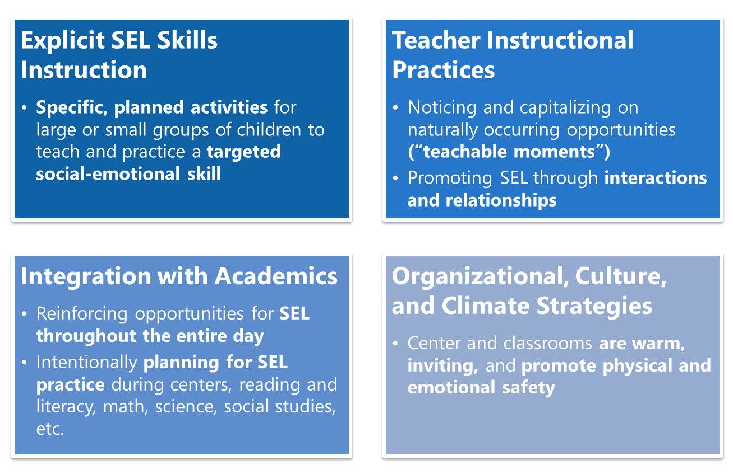

Explicit SEL Instruction
Building Social-Emotional Skills

Effective explicit SEL instruction has four elements represented by the acronym SAFE:
- Sequenced—connected and coordinated activities to foster skills development;
- Active—active forms of learning to help students master new skills;
- Focused—containing activities that clearly emphasize developing personal and social skills;
- Explicit—targeting specific social and emotional skills

Brainstorm: What specific interpersonal awareness and skills would we want to teach using explicit instruction? (Consult the developmental trajectories in the Google Doc for support.)

Sample Scope of Explicit SEL Instruction
Building Social-Emotional Skills

Sample Weekly Plan
Building Social-Emotional Skills

In what ways can we explicitly teach SEL skills each week? What components of this plan jump out to you?

Explicit SEL Skills Instruction: An Example
Building Social-Emotional Skills

As you watch the video, note:
- What are children learning about in this lesson?

- Where do you see evidence of the SAFE elements?

Reflection
Building Social-Emotional Skills

If you DO have an SEL curriculum—do you use it effectively and regularly? If not, how can you improve your implementation? If so, how can you continue to enhance that learning for children?

If you do NOT have an SEL curriculum—what can you do to support the explicit teaching of SEL skills in your classroom? How can these principles still come to life in your classroom?

Planning for Explicit SEL Skills Instruction
Building Social-Emotional Skills

- With your partner(s), select an interpersonal skill to explicitly teach to children.
- Design a brief lesson (or lessons!) that explicitly teaches that skill to children. Keep the SAFE principles in mind!
- Be prepared to share your lesson idea with the whole group!

Interpersonal Skill:
Lesson Plan:

“What’s Learned Here, Leaves Here”
Building Social-Emotional Skills

What are your biggest take-aways from this session?

How will you carry this learning forward in your own work?

