Do Now
Trauma-Informed Teaching in ECE: Part 1

Read the Fred Rogers quote above and reflect on the following:

- What are some of the things our children may have gone through in the past few months?

- What do they need from us, as early childhood educators, right now?

How Trauma Affects Health
Trauma-Informed Teaching in ECE: Part 1

As you watch the video clip, record the things that stand out to you below:

Common Definitions
Trauma-Informed Teaching in ECE: Part 1

Trauma/Adverse Childhood Experiences (ACEs): Adverse childhood experiences, or ACEs, are potentially traumatic events that occur in childhood (0-17 years).
For example:
- experiencing violence, abuse, or neglect
- witnessing violence in the home or community
- having a family member attempt or die by suicide
Also included are aspects of the child’s environment that can undermine their sense of safety, stability, and bonding such as growing up in a household with:
- substance misuse
- mental health problems
- instability due to parental separation or household members being in jail or prison
What experiences might be traumatic?
- Physical, sexual, or psychological abuse and neglect (including trafficking)
- Physical and/or emotional neglect
- Natural and technological disasters, catastrophes, or terrorism
- Family or community violence
- Sudden or violent loss of a loved one
- Substance use disorder (personal or familial)
- Refugee and war experiences (including torture)
- Serious accidents or life-threatening illnesses
- Military family-related stressors (e.g., deployment, parental loss or injury)

Toxic Stress
Trauma-Informed Teaching in ECE: Part 1

Toxic stress explains how ACEs “get under the skin” and trigger biological reactions that lead to those outcomes.
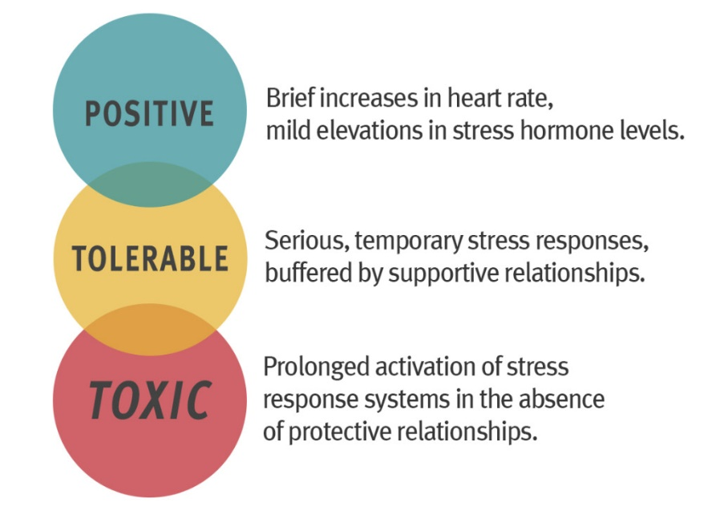

Take 3 minutes to independently reflect:
- How does understanding the brain science of trauma in early childhood make you a better teacher? How can it make you better equipped to support their children?

Expressions of Trauma in Early Childhood Classrooms
Trauma-Informed Teaching in ECE: Part 1

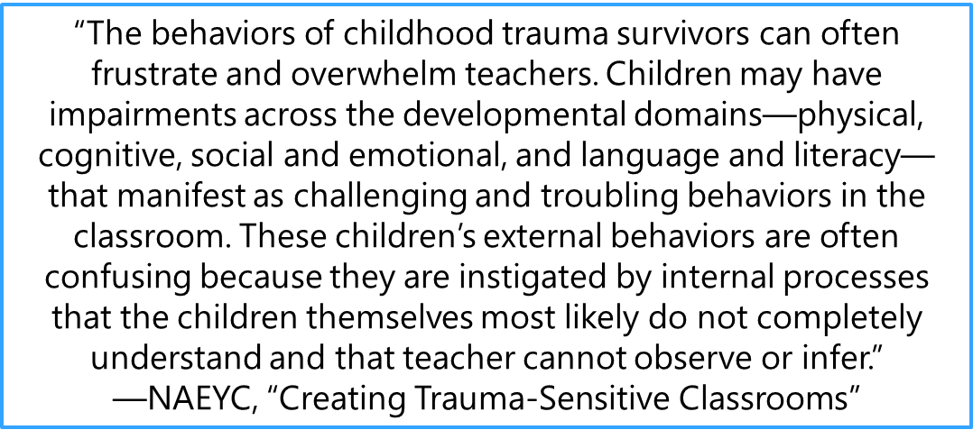
Social Emotional Regulation
A child who has experienced trauma may:
- Be overwhelmed by feelings of fear and stress (brains remain in a state of hyperarousal)
- Have a difficult time regulating their emotions and controlling impulses
- Behave aggressively towards themselves or others
- Misunderstand or be unable to identify the facial and body expressions of others

Language and Communication
A child who has experienced trauma may:
- Struggle to communicate thoughts, feelings, and empathy
- Use and understand primarily “instrumental language” to direct and command behavior (“sit down”, “come here”, “be quiet”, etc.)
- Appear demanding and inflexible
- Communicate using physical responses (hitting, biting, etc.) and/or tantrums

Building Relationships
A child who has experienced trauma may:
- Struggle to interact successfully with peers and teachers
- Not know how to identify and express their feelings with appropriate words
- Keep others at a distance as a way to emotionally, and even physically, protect themselves

Play
A child who has experienced trauma may:
- Struggle to engage in imaginative and creative play
- Become overwhelmed by feelings that emerge during imaginative play
- Avoid initiating play and struggle to resolve conflicts that arise during play

How Do We Move Forward?
Trauma-Informed Teaching in ECE: Part 1

ACEs are preventable. Creating and sustaining safe, stable, nurturing relationships and environments for all children and families can prevent ACEs and help all children reach their full potential.
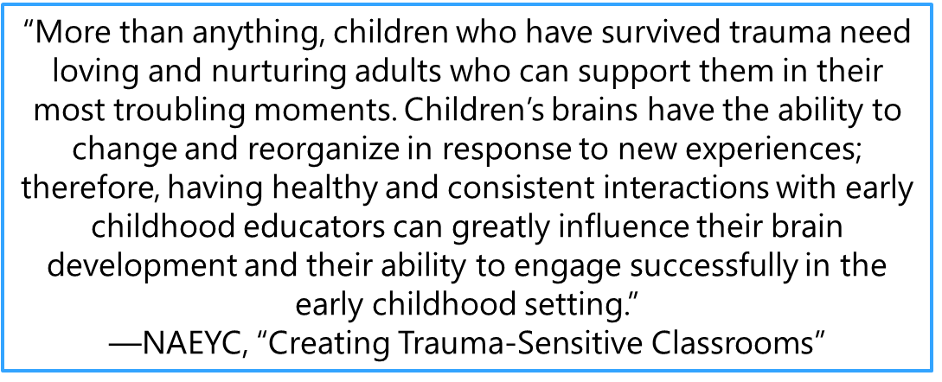
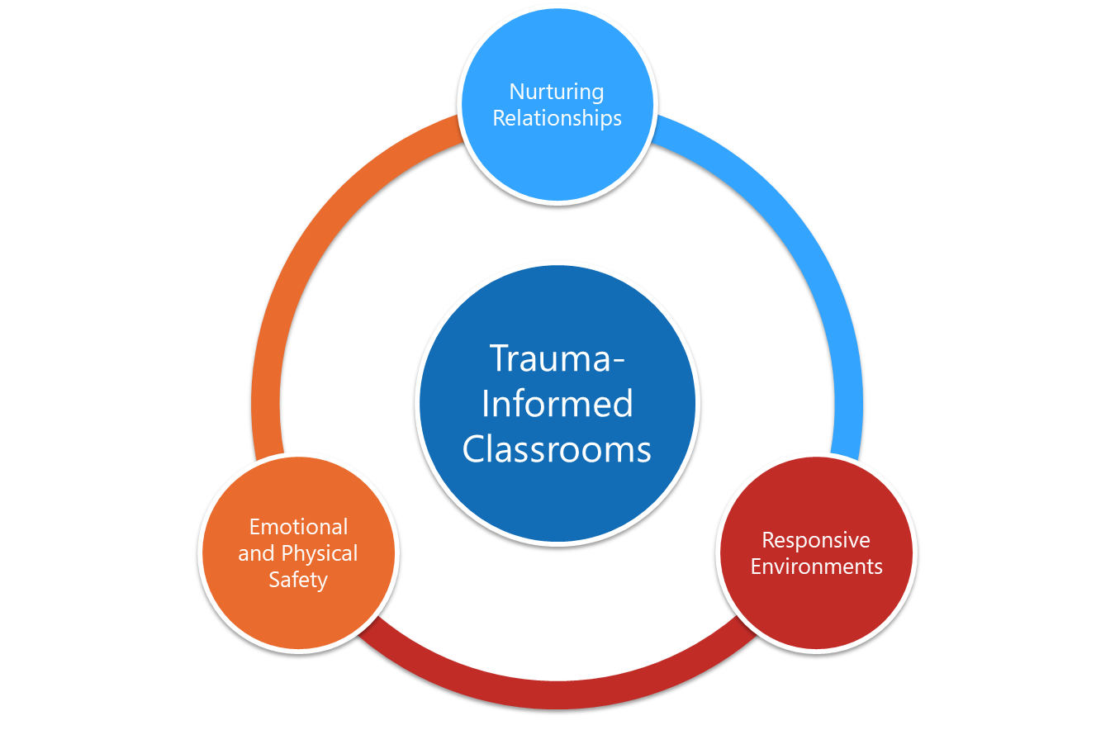

Creating Trauma-Sensitive Classrooms: Emotional Safety
Trauma-Informed Teaching in ECE: Part 1

Safety is a PREREQUISITE.
Emotional Safety: Children experience consistency, safety, and respect.
- Create a space to build relationships
- Transfer power to children and families
- View parents as individuals who have had their own experiences, a child as part of a family, and a family as part of a community.
- Respect diversity through sensitivity to cultural norms, rituals, and parenting styles
Serve and Return Interactions:
As you watch the video, take notes on the five steps of Serve and Return interactions in the table below.
Step | Description | Notes
1 | Notice the serve and share the child’s focus of attention
2 | Return the serve by supporting and encouraging
3 | Give it a name!
4 | Take turns…and wait. Keep the interactions going back and forth
5 | Practice endings and beginnings

Connecting Trauma-Informed Teaching to SEL
Trauma-Informed Teaching in ECE: Part 1

In what ways does social-emotional learning interact and overlap with trauma-informed teaching? How can serve-and-return interactions support both?

Exit Ticket
Trauma-Informed Teaching in ECE: Part 1

Reflect on the following questions and turn them into the facilitator.
- What new learnings about trauma-informed teaching are you taking away from today’s training?

- Was anything surprising to you? What questions do you still have?

- How will you use serve and return interactions and other strategies to build nurturing, responsive relationships with all your children?

