Do Now
Trauma-Informed Teaching in ECE: Part 3

Think about your own experience in coping with the new realities that have come with the coronavirus pandemic.

- What emotional and physical responses have you experienced in the past four months?

- How have you managed those responses? How have you relied on others to help you?

Managing Hardship in the Time of COVID
Trauma-Informed Teaching in ECE: Part 3

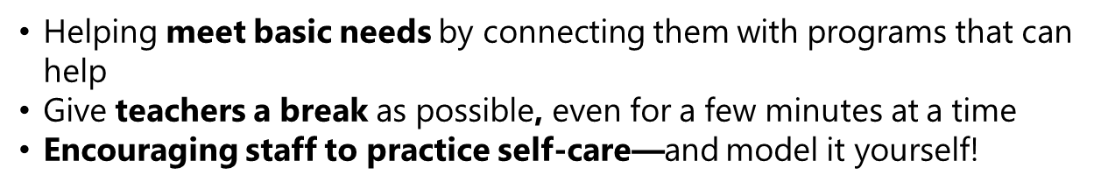

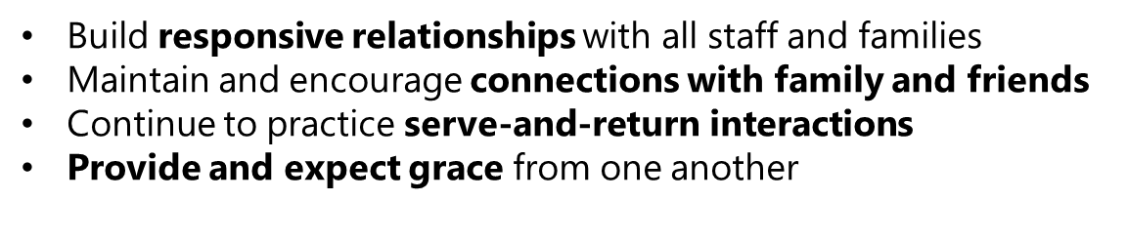
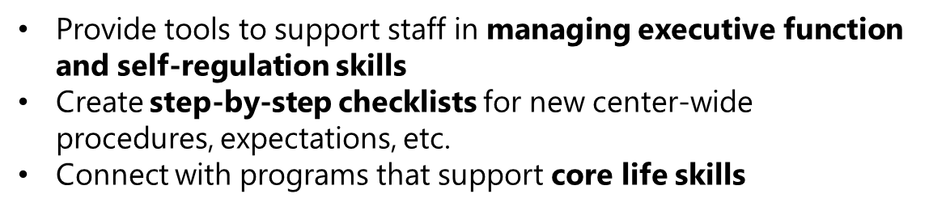

Reflection
Trauma-Informed Teaching in ECE: Part 3

How can you apply the three previous principles to support yourself and your colleagues in managing hardship?

Recognizing Common Symptoms of Stress
Trauma-Informed Teaching in ECE: Part 3

If you or your colleagues (or your families) are exhibiting some of the symptoms below, it may be an indicator of unhealthy levels of stress:
- Feeling irritation, anger, or in denial
- Feeling uncertain, nervous, or anxious
- Lacking motivation
- Feeling tired, overwhelmed, or burned out
- Feeling sad or depressed
- Having trouble sleeping
- Having trouble concentrating
- Physical reactions, such as headaches, body pains, stomach problems, and skin rashes
- Changes in appetite, energy, and activity levels

Concrete Support Strategies:
Social | Emotional
- Cultivate and maintain supportive relationships with all staff members  - Plan for safe, socially-distanced, face-to-face time  - Support managing personal and professional needs  - Find ways to stay connected to the community  - Connect staff to resources | - Allow safe places to process emotions  - Air feelings and talk through problems  - Build in time for breaks  - Develop a professional support system  - Support practicing mindfulness across your school or center  - Give your staff (and yourself) grace as you move through this complex time

Planning to Support Yourself and Your Colleagues
Trauma-Informed Teaching in ECE: Part 3

How can I…. | For myself: | For my colleagues:
- Reduce sources of stress
- Provide positive experiences (i.e. through responsive relationships)
- Strengthen core life skills
- Support social well-being
- Support emotional well-being

