Do Now
Understanding the Development of Social-Emotional Skills

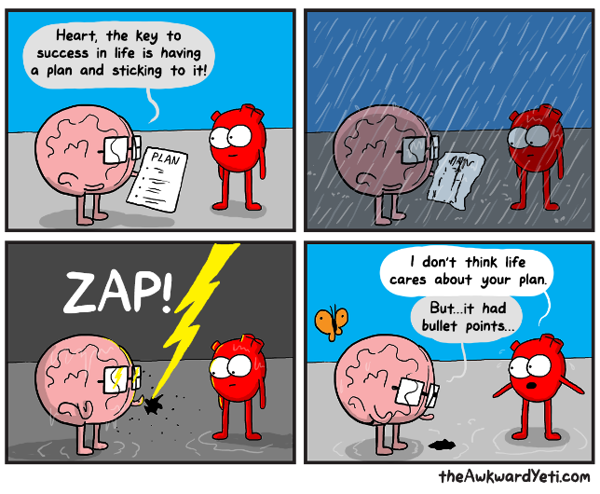

Read the cartoon above and respond to the following questions:
- What ARE the key traits/attitudes/mindsets/ skills to being successful in life?

- What traits would you identify as most important when you need to “weather a storm”?

SEL is…
Understanding the Development of Social-Emotional Skills

“Social and emotional learning (SEL) is an integral part of education and human development. SEL is the process through which all young people and adults acquire and apply the knowledge, skills, and attitudes to develop healthy identities, manage emotions and achieve personal and collective goals, feel and show empathy for others, establish and maintain supportive relationships, and make responsible and caring decisions.
SEL advances educational equity and excellence through authentic center- or school-family-community partnerships to establish learning environments and experiences that feature trusting and collaborative relationships, rigorous and meaningful curriculum and instruction, and ongoing evaluation. SEL can help address various forms of inequity and empower young people and adults to co-create thriving center and schools and contribute to safe, healthy, and just communities.”

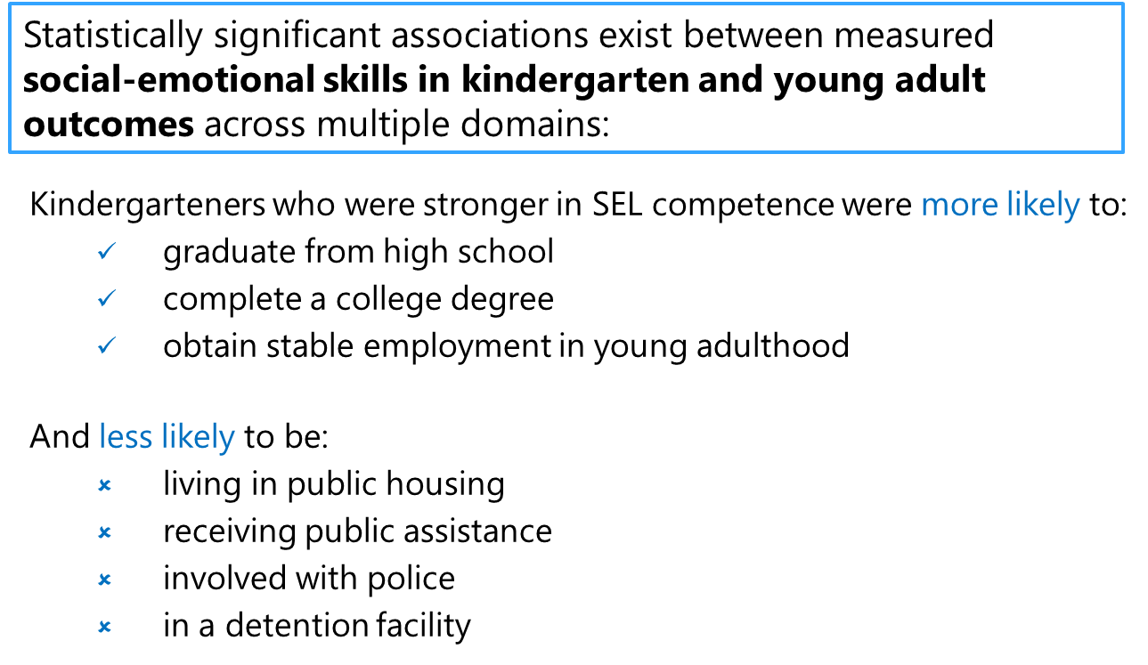
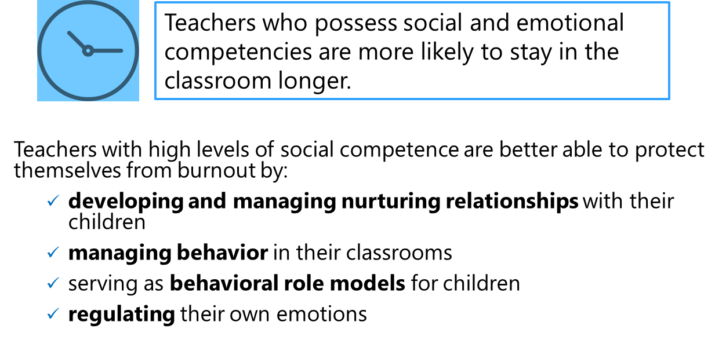

Brain Architecture: We Are Laying the Foundation
Understanding the Development of Social-Emotional Skills

As you listen to this clip from “The Brain Architects” podcast, jot down anything that jumps out to you.
(Link: https://developingchild.harvard.edu/resources/the-brain-architects-podcast-brain-architecture-laying-the-foundation/)

Reflection: What are the implications for your work as an early childhood teacher as you consider laying a strong foundation for children in the earliest years?

The Five SEL Competencies
Understanding the Development of Social-Emotional Skills

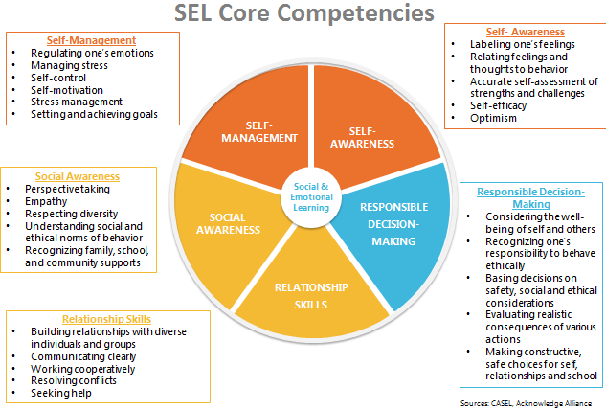

Reflecting on the Developmental Trajectories
Understanding the Development of Social-Emotional Skills

What SEL competencies do you feel you understand deeply already? Which areas will you need to keep in mind the most?

SEL in Action
Understanding the Development of Social-Emotional Skills

SEL Clip 1:
- What evidence do you see of the five SEL competencies in action, from the teacher and/or children?

- How do you notice teachers supporting children along the developmental continuum of social-emotional learning?

SEL Clip 2:
- What evidence do you see of the five SEL competencies in action, from the teacher and/or children?

- How do you notice teachers supporting children along the developmental continuum of social-emotional learning?

Exit Ticket
Understanding the Development of Social-Emotional Skills

Reflect on the following questions:
- How can we use the science of the developing brain to support children in our classrooms?

- How does understanding the developmental trajectory of social-emotional skills support your ability to interact with and teach your children?

