Do Now
Culturally Responsive Teaching in ECE: Part 3

Reflect on any past equity or diversity training you have experienced in your adult life and career.

What insights and understandings about implicit bias are you bringing to your work as a culturally responsive educator?

What is Culturally Responsive Teaching?
Culturally Responsive Teaching in ECE: Part 2

Culturally Responsive Teaching (CRT) is “an educator’s ability to recognize students’ cultural displays of learning and meaning-making and respond positively and constructively with teaching moves that use cultural knowledge as a scaffold to connect what the student knows to new concepts and content in order to promote effective information processing. All the while, the educator understands the importance of being in relationship and having a social-emotional connection to the student in order to create a safe space for learning.”
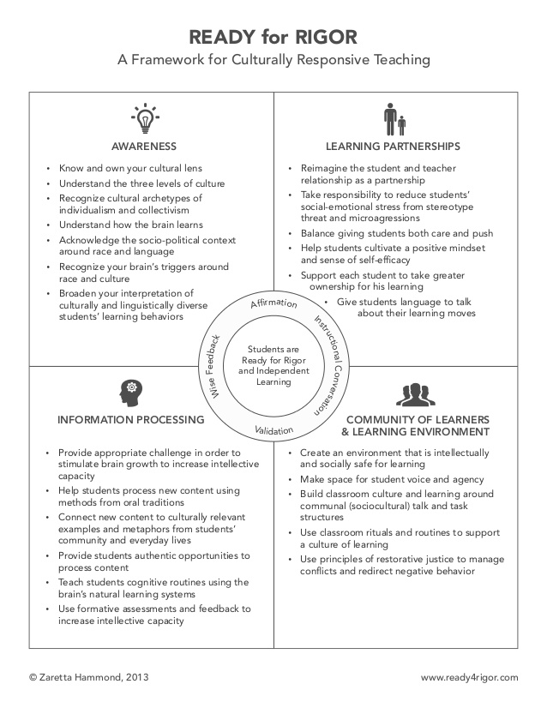
Unpacking Our Implicit Bias
Culturally Responsive Teaching in ECE: Part 3
“The real voyage of discovery consists not in seeking new landscapes, but in having new eyes.” Marcel Proust
Begin with an Intention: Intention is the starting point for preparing yourself for improving your culturally responsive teaching practice. The act of committing to the process primes your brain and activates your will. The commitment to be an effective culturally responsive educator builds the stamin and courage to persevere when the process gets challenging. “The journey of a thousand miles begins with a single step.” Lao Tzu
My intention in becoming a culturally responsive practitioner:

Self-Examination—Making the Familiar Strange: Learning about our own culture is far more challenging than learning about the culture of others. A critical first step is to understand how our own cultural values shape our expectations in our classrooms and centers—from how we expect children to engage socially, to turn-taking during conversations or activities, or even treating materials. Culturally responsive teaching asks us to take the emotional risk to examine the deeply held beliefs that influence how we respond to children—and that inward reflection means being willing to listen and change in order to respond positively and constructively to culturally diverse children.
- There are three internal tasks every educator has to work through to uncover implicit bias and prepare to work with culturally and linguistically diverse children.
- Identify your cultural frame of reference
- Widen your cultural aperture
- Identify your key triggers

Practicing Emotional Self-Management: Self-management involves being aware of one’s feelings and the ability to use this awareness as information to manage and adjust one’s emotional state—just like we ask children to do as they’re developing their own self-awareness and self-management! For a culturally responsive educator, this practice is critical.
- Identify what sets you off: Think about—what makes you most defensive? By thinking this through in advance, you’re using your prefrontal cortex and programming it to keep your amygdala in check.
- Label your feelings when they come up: Labeling these feelings helps reduce their intensity and returns some cognitive control. This process helps us reframe negative feelings, thereby reducing their impact.
- Create an early warning system: By paying attention to signs and emotions you can take action early rather than allowing raw emotion to take over. Notice your physical reaction, and take the cue from your body to step back and regroup.
Identify Your Cultural Frames of Reference
Culturally Responsive Teaching in ECE: Part 3

Use the culture tree and the guiding questions below to begin to examine your own cultural frames of reference.
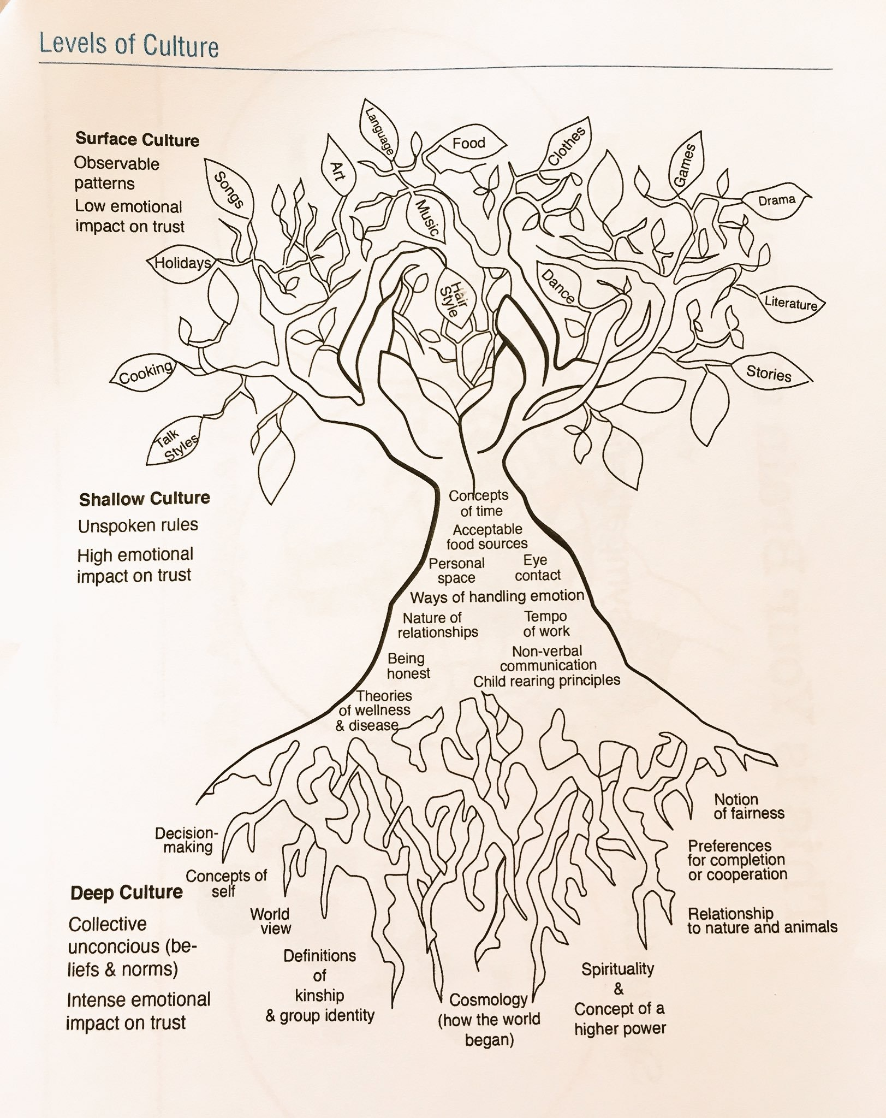

Think about your surface culture:
- How did your family identify ethnically or racially?
- Where did you live—urban, suburban, or rural community?
- What is the story of your family in America? Has your family been here for generations, a few decades, or just a few years?
- How would you describe your family’s economic status—middle class, upper class, working class, or low income? What did that mean in terms of quality of life?
- Were you the first in your family to attend college? If not, who did—your parents, grandparents, or great-grandparents?
- What family folklore or stories did you hear regularly while growing up?
- What are some of your family traditions—holidays, foods, or rituals?
- Who were the heroes celebrated in your family and/or community? Why? Who were the antiheroes? Who were the “bad guys”?
Think about your shallow cultural beliefs and experiences:
- What metaphors, analogies, parables, or “witty” sayings do you remember hearing from parents, grandparents, aunts, and uncles?
- What family stories are regularly told or referenced? What message do they communicate about core values?
- Review primary messages from your upbringing: What did your parents, neighbors, and other authority figures tell you respect looked like? Disrespect?
- How were you trained to respond to different emotional displays—crying, anger, happiness?
- What physical, social, or cultural attributes were praised in your community? Which ones were you taught to avoid?
- How were you expected to interact with authority figures? Was authority of teachers and other elders assumed or did it have to be earned?
- What got you shunned or shamed in your family?
- What earned you praise as a child?
- Were you allowed to question, or talk back to, adults? Was it okay to call adults by their first name?
- What’s your family/community’s relationship with time?
Think about your deep cultural values:
- What were the norms for communication in your family and community?
- How were you expected to “do school” while growing up?
- What drove your motivation growing up? How does that reflect the values instilled from your family and community?
- What learning behaviors were you raised to believe everyone should exhibit? (Talk and discourse patterns, volume of interaction, time on task, collaboration or individual work, etc.) How did you come to believe this?
- What messages did you get about why other racial or ethnic groups succeeded or not?
- What did your culture teach you about intelligence? Did you grow up believing it was set at birth? Did you believe it was genetic? Did you believe some groups were smarter than others?
- How does your culture define fairness? Does it differ for different groups?

Reflection
Culturally Responsive Teaching in ECE: Part 3

How will examining your own surface, shallow, and deep culture (using the questions provided in your handouts as a starting point) support you in understanding your own culture?

How will understanding your own culture make you a more effective culturally responsive educator?

Widen Your Interpretation Aperture
Culturally Responsive Teaching in ECE: Part 3

Widen your interpretation aperture:
- Broaden your body of explanations and interpretations of child actions
- Develop a process that allows us to expand our ability to recognize the different ways things are done in other cultures
- Let in alternative explanations for a child’s learning behaviors and social interactions that look different from our own
What is the deficit thinking paradigm?
When operating from a deficit thinking paradigm, educators and policymakers believe that culturally and linguistically diverse children fail in school because of their own deficiencies or because their families don’t value education, not because of social inequities, unfair systems, or differential treatment in the classroom. There is an ill-informed belief that a child’s failures are attributable to a lack of intellectual ability, linguistic inferiority, or family dysfunction. This deficit perspective suggests that efforts to improve achievement should be focused on “fixing” children rather than shifting the culture to support a child’s capacity building and creating identity-safe classrooms so that children can access their potential. As a result, teachers’ deficit-oriented attributions of child performance influence their decision-making, resulting in giving children less opportunity in the classroom.
It is our brain’s natural inclination to default to a deficit thinking paradigm (the brain’s “negativity bias”). How can widening our interpretation aperture prevent us from falling into that bias?

Identify Your Key Triggers
Culturally Responsive Teaching in ECE: Part 3

Identify your key triggers:
- Communicating across cultures opens up the potential for miscommunication and unintended conflict
- When our brain’s alarm system gets triggered, we become culturally reactive in an effort to protect ourself rather than culturally responsive to the other person we are interacting with
- Culturally responsive educators know themselves well enough to anticipate situations that might trigger them, and manage those emotions to avoid an amygdala hijack
Element | Description | What’s the Threat
Standing | Standing refers to one’s sense of importance relative to others in one’s social network or organizational hierarchy (e.g., peers, coworkers, friends, supervisors). It also relates to how one believes others in the group perceived him—negative or positive, competent or incompetent. | The fear that one would be expelled from the “tribe” (such as being fired from a job, evaluated poorly by a leader, ostracized by peers for doing things differently).
Certainty | Certainty refers to one’s need for clarity and predictability in a social situation in order to make accurate social moves. It also relates to one’s ability to predict what will happen (e.g., routines, cause and effect, action and reaction). | The fear of possibly embarrassing oneself or being unable to know what to do in a given situation. The feelings of being out of control or unable to be safe because of venturing into the unknown with new teaching practices or unfamiliar ways of organizing the classroom.
Control | Control speaks to one’s sense of control over his life and the perception that one’s behavior can have a positive effect on the outcome of a situation (e.g., getting a promotion, finding a partner) rather than something out of his control having more influence (e.g., class, race, language, or gender). | The fear of someone telling you what to do, where to go, and how to behave that is inconsistent with your values (such as English only laws or Jim Crow laws).
Connection | Connection focuses on one’s sense of relatedness to and security with another person, one’s family, or one’s peer group. It also is concerned with whether new people one interacts with are friend or foe. | The fear of being an outsider and excluded. We fear losing important connection with others. People do not want to be out of relationship with others, especially an important peer group.
Equity | Equity refers to having a sense of fair, just, and nonbiased exchange between people (e.g., equal opportunity, equivalent pay for equivalent work, the elimination of unearned advantage and disadvantage). | The threat can come when one feels he or his group (class, geographic, linguistic, etc.) is being subjected to unearned disadvantage or someone is receiving unearned advantage. It may also be associated with distancing oneself from unearned advantage.

Reflection
Culturally Responsive Teaching in ECE: Part 3

What are some behaviors from children or families that might trigger you?

How can you identify those triggers to manage your own emotions and remain in a culturally responsive mindset?

“What’s Learned Here, Leaves Here”
Culturally Responsive Teaching in ECE: Part 3

What are your biggest take-aways from this session?

How will you carry this learning forward in your own work?

How will this impact your work with the children in your classroom?

