Do Now
Culturally Responsive Teaching in ECE: Part 1

What has been your experience (if any) up to this point with culturally responsive teaching?

How would you define culture?

“Children Grow Into the Intellectual Life Around Them”
Culturally Responsive Teaching in ECE: Part 1

As you watch Zaretta Hammond discuss the foundation of Culturally Responsive Teaching (CRT), take notes on the following questions:
- What are your biggest take-aways from this video?

- What do you do to “set children’s brains on fire” and build academic mindset (chart below)?

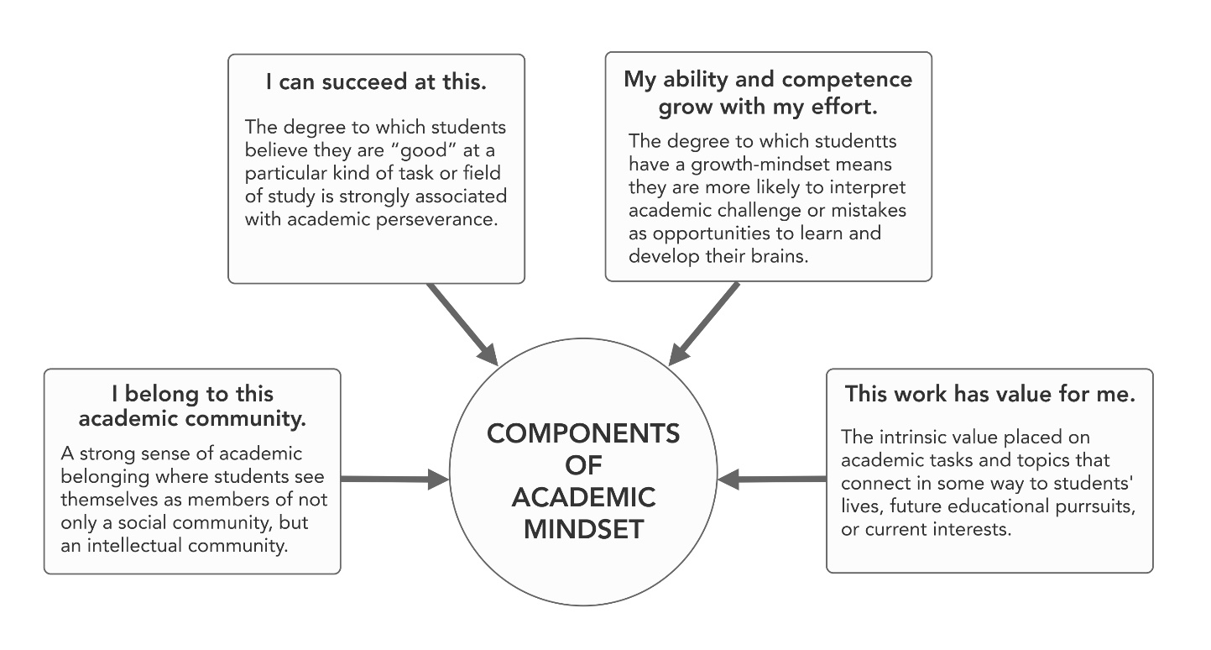

What is Culturally Responsive Teaching?
Culturally Responsive Teaching in ECE: Part 1

Culturally Responsive Teaching (CRT) is “an educator’s ability to recognize students’ cultural displays of learning and meaning-making and respond positively and constructively with teaching moves that use cultural knowledge as a scaffold to connect what the student knows to new concepts and content in order to promote effective information processing. All the while, the educator understands the importance of being in relationship and having a social-emotional connection to the student in order to create a safe space for learning.”
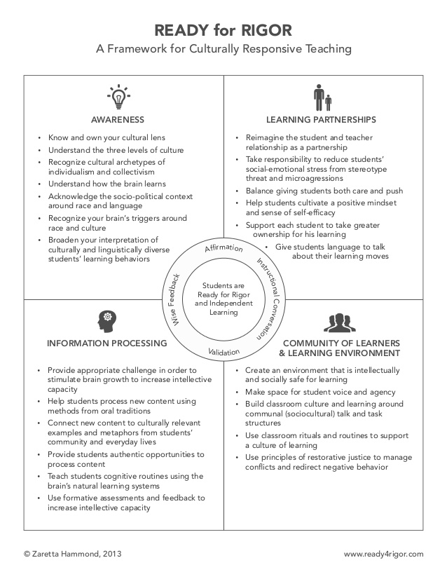
Awareness: Understanding the Roots of Culture
Culturally Responsive Teaching in ECE: Part 1

“Teachers need adequate background knowledge and usable information in order to know how to apply culturally responsive tools and strategies. Building background knowledge begins with becoming knowledgeable about the dimension of culture as well as knowledgeable about the larger social, political, and economic conditions that create inequitable education outcomes.”

Key Definitions:
Culture: the way that every brain makes sense of the world, like software for the brain’s hardware. The brain uses cultural information to turn everyday happenings into meaningful events.
- Surface culture: Observable and concrete elements of culture such as food, dress, music, and holidays. This has a low emotional charge.
- Shallow culture: The unspoken rules around everyday social interactions and norms, such as courtesy, attitudes towards elders, nature of friendship, concepts of time, personal space between people, nonverbal communication, appropriate eye contact and touching, etc. This level has a strong emotional charge—it’s how put into action our deep cultural values.
- Deep culture: The tacit knowledge and unconscious assumptions that govern our worldview. Also contains the cosmology (view of good or bad) that guides ethics, spirituality, health, and theories of group harmony (i.e. competition or cooperation). Also governs how we learn new information. This level has an intense emotional charge—challenges at this level produce culture shock or trigger the brain’s fight or flight response.
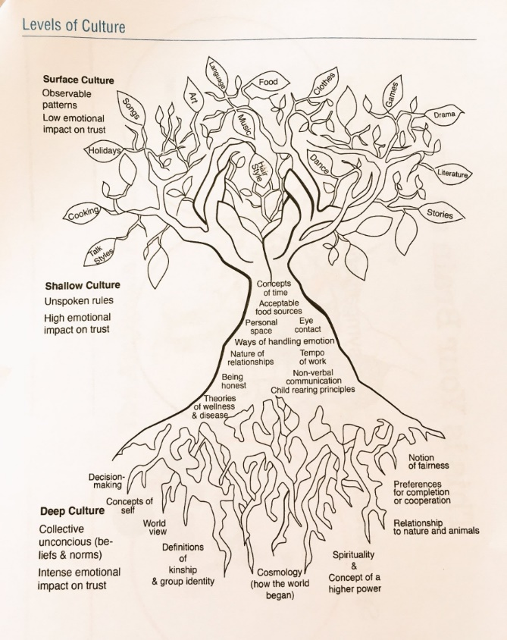
Cultural Archetypes: universal patterns across cultures
- Collectivism: Societies that emphasize relationships, interdependence within a community, and cooperative learning. (dominant culture in many AA, Latino, Pacific Islander, and Indigenous communities). How collectivism is expressed varies, but focus on relationships and cooperative learning stays the same.
- Individualism: Societies that emphasize individual achievement and independence. (dominant culture in America)
- Oral tradition: Recording and sustaining cultures and cultural identities by word of mouth; telling stories and coding knowledge into songs, chants, proverbs, and poetry. Makes the most of the brain’s memory systems by using alliteration, movement, and emotion as strong cognitive anchors.
- Written tradition: Does not require much person-to-person interaction or dialogue because thoughts are committed to print.
Sociopolitical Context: The series of mutually reinforcing policies and practices across social, economic, and political domains that contribute to disparities for people of color in housing, transportation, education, and health care, to name a few. Unequal opportunities resulting in unequal outcomes along race and class lines.
- Implicit Bias: The unconscious attitudes and stereotypes that shape our responses to certain groups. Operates involuntarily, often without one’s awareness or intentional control.
- Structural Racialization: The factors within society’s systems (housing, education, healthcare, etc.) that interact to create and perpetuate social, economic, and political structures that are harmful to people of color and to our society as a whole.

Sociopolitical Context vs. the “Culture” of Poverty
Culturally Responsive Teaching in ECE: Part 1

“There’s considerable research that clearly states that people in poverty are not, in fact, lazier, less likely to value education, or more likely to be substance abusers than their wealthier counterparts. Yet, implicit racial bias reinforces the notion of people of color willingly living in poverty or unmotivated to charge their circumstances. This view ignores the contributing factors of structural racialization in society that limit a family’s economic and educational opportunities.”
- Poverty is NOT a culture: Poverty is a condition or symptom of the structural inequities built into our social and economic systems. Poverty for most families is not a lifestyle choice. Poverty doesn’t fit the definition of culture in that it doesn’t have deep cultural roots governed by a cosmology or worldview.

- Coping skills are mistaken for norms and beliefs: What appears to be a “culture”—norms, beliefs, and behaviors that are transmitted from one generation to another—are more accurately coping and survival mechanisms that help marginalized communities navigate racial and economic caste systems; due to the often generational nature of poverty, these coping mechanisms become codified and misconstrued as “culture”.

- Poor people do not normalize or glorify negative aspects of living in poverty: Despite images we commonly see in popular media, negative aspects of living in poverty (drug use, violence, etc.) are not normalized and embraces as lifestyle choices by poor people. Often, those behaviors are an outgrowth of post-traumatic stress disorder (PTSD). As many as one-third of children living in our country’s urban neighborhoods have PTSD—nearly twice that reported for troops returning from war zones in Iraq. (Stanford’s Early Life Stress Research Program, 2007.)

Reflection
Culturally Responsive Teaching in ECE: Part 1

Which levels of your children’s culture do you know the most about? Which do you know the least about?

Brainstorm
Culturally Responsive Teaching in ECE: Part 1

What are the different ways you could operationalize the different levels of culture in your classroom? (Reference back to the Culture Tree for examples of surface, shallow, and deep culture.)
Surface Culture | Shallow Culture | Deep Culture

