Do Now
Culturally Responsive Teaching in ECE: Part 2

Recall an important teacher in your own life. How would you describe the relationship? What made it feel like a partnership?

How do you build relationships across difference?

Start with Responsive
Culturally Responsive Teaching in ECE: Part 2

As you listen to the “blogcast”, respond to the following questions:
- What is the “true starting point” for culturally-responsive teaching?

- What are your major takeaways from this brief blogcast?

What is Culturally Responsive Teaching?
Culturally Responsive Teaching in ECE: Part 2

Culturally Responsive Teaching (CRT) is “an educator’s ability to recognize students’ cultural displays of learning and meaning-making and respond positively and constructively with teaching moves that use cultural knowledge as a scaffold to connect what the student knows to new concepts and content in order to promote effective information processing. All the while, the educator understands the importance of being in relationship and having a social-emotional connection to the student in order to create a safe space for learning.”
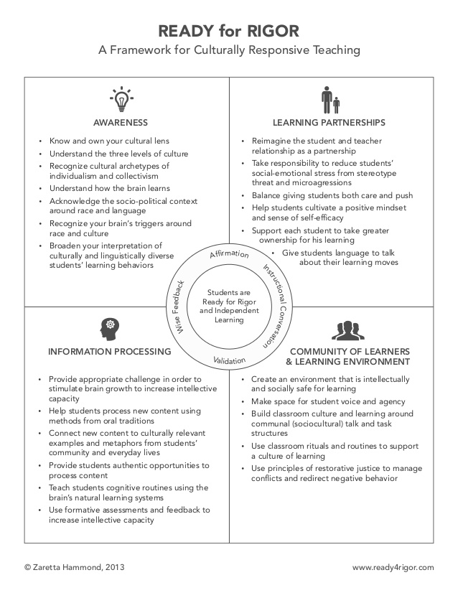
Trust Generators
Culturally Responsive Teaching in ECE: Part 2

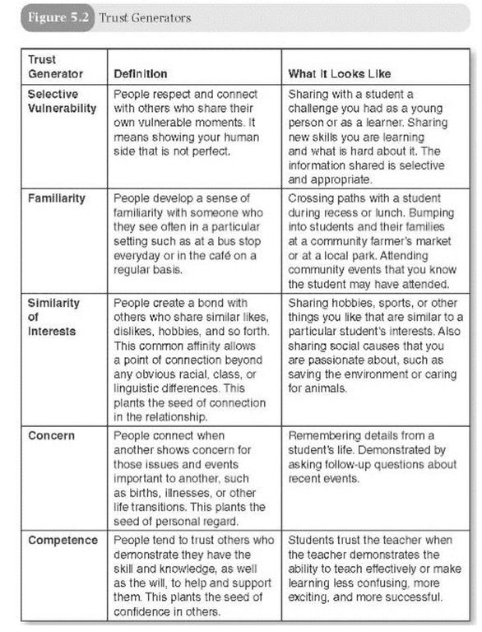
Reflection
Culturally Responsive Teaching in ECE: Part 2

How do you create a sense of trust and rapport in your relationships with children?

What do you do deliberately? What do you do randomly?

My Points of Connection
Culturally Responsive Teaching in ECE: Part 2

Use the worksheet below to reflect on how you might use the trust generators to build more authentic connections with your children.
My Points of Connection
- What do you see as the best points of connection you can make with your children?

In the space on the right, identify a few experiences or stories you might share based on some combination of the trust generators.
Trust Generators:
- Selective Vulnerability
- Familiarity
- Similarity & Interests
- Concern
- Competence

“What’s Learned Here, Leaves Here”
Culturally Responsive Teaching in ECE: Part 2

What are your biggest take-aways from this session?

How will you carry this learning forward in your own work?

