Nevada Math Series
Session 5

Do Now
Building Math Skills—Math in its “Natural Environment” and STEM

source: http://www.valpoymca.org/assets/images/Child%20Care/STEM/STEM_Infographic.jpg

Jot down where and how you see the importance of science, engineering, and technology in the world around you. Why do we need to make these connections for our children?

Why STEM?
Building Math Skills— Math in its “Natural Environment” and STEM

“Understanding the world around them is one of the strongest predictors of young children’s later science learning and reading, and a significant predictor of mathematics success.”

Grissmer, et. al., Developmental Psychology, 2010
What is early STEM?

Source: Brooklyn Public library, adapted from the Boston Children’s Museum STEM Teaching Guide
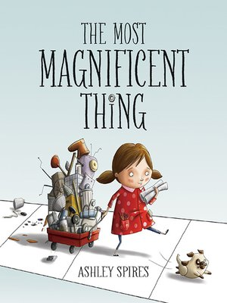
Literacy Connections
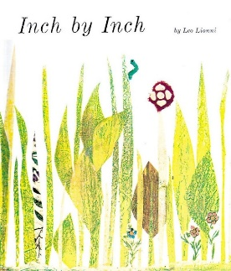

Excellence in Action: Engineering and Technology
Building Math Skills— Math in its “Natural Environment” and STEM

As we watch the video, answer the following questions:
What connections can you make between the video and the vision of math we’ve built thus far in our series?
How do you see children engaging in…
Problem-solving? | Reflecting on their approach to problems? | Productive struggle?

Extend your thinking: What connections do you see to the rubric?

Excellence in Action: Science
Building Math Skills— Math in its “Natural Environment” and STEM

As we watch the video, consider: What connections can you make between what you see in this video and the vision of math we’ve built thus far in our series?

STEM in Action Gallery Walk
Building Math Skills— Math in its “Natural Environment” and STEM

How do we plan effectively for STEM opportunities?
Key Idea: Effective STEM opportunities are intentionally planned to align to math standards, build children’s problem-solving skills, support them in productive struggle, and support them to explain their thinking.
1-Independently: Read through the NAEYC article for the static electricity task or the circuits task (depending on what you are assigned).
2-In pairs: Break down the static electricity task or the circuits task with a partner.
What did children do in this task?
How did this further their understanding of math and make STEM connections?
What type of thinking did children do?
What type of math vocabulary and/or math talk was involved?
What made this task effective?
How was this task connected to the standards?
Continue to the next page for your group discussion notes.

3-In groups of 4: Discuss what made these activities effective.
What did you hear from your partners about the other activity that you want to note?
What steps are needed in planning to ensure a STEM activity is fruitful and effective for children?

As a whole group we will discuss: What centers/stations/activities in your rooms do you already have that support science exploration? Feel free to jot down notes here if that’s useful.

Planning for STEM
Building Math Skills— Math in its “Natural Environment” and STEM

Key Idea: As we know, it’s not enough for us to explain a concept to a teacher or child, we need to make the explanation fun and engaging through intentional activities and classroom opportunities.

- Based on our group brainstorming (what centers/stations/activities in your rooms do you already have that support STEM exploration?) pick one to focus on.
- We want to consider: How can you use those opportunities that already exist (like water tables, block tables, etc.) and plan more intentionally for them instead of feeling like you need to create something brand new?
- Use the guided process below to plan intentionally to use that center/station/activity to make STEM connections.

What center/station/activity did you select?
Why? How does this center/station/activity support STEM exploration?
What age of students are you working with?
Goal: What STEM focus/skill/concept do you want to introduce students to? What do you want them to be able to do?
Describe the activity you would plan for this.
Be sure to address: What problem will students work to solve?

Continue to the next page for the rest of your planning.

How do you expect students to collaborate, research, communicate, ask questions during this activity?
What THREE questions will you ask during the activity to build problem-solving and reasoning skills?

What standards does this connect to?

How does this connect to real-life?
What opportunities for math talk exist in this center/station/activity tied to STEM? What vocabulary will you emphasize?

Partner Feedback
Glow
Grow

Leader Planning
Building Math Skills— Math in its “Natural Environment” and STEM

Take the next several minutes to create a plan for how you will share this content with the center staff and/or teachers that you support.

- When will you deliver this content to your staff or the teachers you work with?

- How will you deliver content to your staff or the teachers you support? (One whole-group two-hour professional development? Smaller groups? Smaller chunks of time? Direct facilitation vs. small group planning?)

- How will you support the teachers you work with in integrating STEM? What tools will you create and provide them with?

- What challenges do you anticipate the teachers you support may have with this content?

Do Now
Practice: Observing for STEM

Reflect on your experience making time for math observations.
How have you gathered the data you need from classroom observations?

What has worked well for you to make sure you input the data and make use of it in a timely manner to support teachers?

Observation Practice
Practice: Observing for STEM

Collect data across the entire rubric (all performance areas) for teacher and student actions.

Rating on the Rubric Reminder
Practice: Observing for STEM

HOW TO RATE FOR OVERALL PERFORMANCE
- Decide on your rating for each indicator.
- Consider the ratings for all the indicators under a particular competency (i.e.. Essential Content).
- Using your evidence and indicator ratings, assign an overall rating to that competency: Ineffective, Approaching Developing, Developing, Proficient.
- Write 2-3 evidence statements that support your overall rating.
- Repeat for each relevant competency.

How would you rate what we observed on the rubric? Does this teacher’s instruction exemplify what we identified as critical for math and STEM concepts?

What is emerging to you as a primary area of development? (You don't have to fully commit to your area of development quite yet - more evidence is coming!)

Exit Ticket
Practice: Observing for STEM

With just one session in the math leadership series remaining, reflect on how you feel you can best use the observation tool in your work.

Write one strength you want to keep building on with the rubric, one challenge you face, and one way you plan to address that challenge before our work together is complete.
Strength
Challenge
One way to address the challenge

