Nevada Early Childhood Math Leadership Series Session 3: Gallery Walk
Jan 2018

Object Permanence
Object permanence refers to the knowledge that an object is there even when it cannot be seen (Cole, Cole, & Lightfoot 2005).

- Object permanence is an essential step in an infant’s cognitive development because understanding object permanence leads to an understanding of their world and an awareness that will allow them to learn, imitate, and explore.
- Through exploration of the environment and peek-a-boo and other games that involve hiding objects, a teacher can support children’s emerging awareness of the environment around them (Brazelton & Sparrow 2006).
- This ties to spatial reasoning and to attending to objects—which is foundational for understanding one-to-one correspondence.
Reasoning and concept development
Once toddlers grasp object constancy, sorting by size and color is almost within reach. (http://teacher.scholastic.com/professional/childdev/thepath_toMath.htm)

Examples of how you might develop this:
- an object of interest being partially covered/fully covered with a cloth –and then uncovered
- pushing a train through a tunnel
- putting toy cars in a garage
- looking at a jack-in-the box.
- The focus here is on attending to objects, and while this seems simple, it’s critical to develop in our youngest learners.

More (Comparison/Quantity Concepts)
More refers to a greater quantity. Important: More ≠ bigger or larger.

- The concept of “more” lays the foundation for other comparison words and quantity concepts, like “same” and “less.”
- Children do not have to count to be able to identify more.
- “More” will be used in greater complexity at later ages (and children can be pushed to expand upon how they know a group has more as they develop their math vocabulary).

More is a pretty ‘standard’ concept and one of the first concepts infants develop. Like other concepts, we can teach more in several ways. It underpins so much of what children will be asked to do in more complex math that it’s essential we don’t skip over this. It’s also important to nuance the difference amongst more, bigger, and larger. We sometimes use these words interchangeably, but they are not the same. If I put a bowl with 10 cherries next to a bowl of 8 grapefruits and asked a two-year old which had more, they would likely pick the grapefruit and not attend to quantity but rather size.

We make a quick connection to Shel Silverstein’s poem. In the poem, a boy starts out with a dollar bill and keeps exchanging/trading so that he has more in number of coins/items. One-dollar bill becomes two quarters becomes three dimes…and at the end the boy has five pennies. In this poem we see at a pretty simple level how important math concepts are—here, understanding more is vital…but also understanding more in context of $ and what the value of that money is. There are so many nuances to the concept of more—and it’s also why we can’t just brush off learning with a rote definition or surface-level understanding.
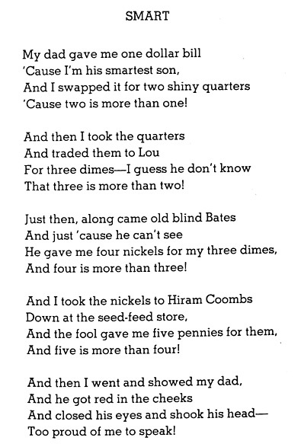

One
One refers to singular objects.

- With infants, we focus on having them identify singular objects of one.
- With toddlers, we build on this concept to further their understanding of quantity:
  - identify one,
  - more than one,
  - less than one, etc.
- This lays the foundation for students to understand one-to-one correspondence during counting (matching one object with each number)

As you can see from the notes (and as might make sense to you when you think about the concept of one), more and one go together. When we think about how we want children to understand one, we want them to be able to identify singular objects of one. This may sound quite simplistic—and again, like object permanence and more, it is! Again, it is also foundational.
Let’s consider something as “simple” as counting. The concept of hierarchical inclusion means that each number represents one more than the previous number in the counting sequence and includes all previous numbers within it. For counting to make sense to us, we must understand the idea of one more than the previous number—a building block in our math learning.
Here is an example of hearing quantity labels expressed in conversation: “You have one cracker. Would you like one more?” Following snack set-up instructions: “Let’s give everyone a napkin. Put one here and one there

Numeracy
Numeracy refers to the ability to understand and work with numbers (i.e. number sense!).

- Quantity = amount Note: generally does not refer to the amount of space something takes up!
- Verbal = saying the number Think: counting aloud. Does not need to be connected to a written numeral.
- Symbol = the numeral(s) attached to a number i.e. recognizing the numeral 4 or knowing that 14 is made up of the numerals 1 and 4.

These 3 concepts underpin students’ number sense or numeracy (you may hear the terms used interchangeably and should not be thrown off). We think/speak/work with numbers in 3 different ways. It is important to make connections among all 3 to help build a solid foundation.

One in isolation of the other can be appropriate for a younger child (i.e. a child may develop an understanding of quantity before being able to verbally express that). However, in time, children need all 3 to be successful in math and effectively using number sense.

