Do Now
Choosing Complex Texts for Read Alouds in Early Childhood

Take a few minutes to respond to the following questions:
How would you describe a complex, worthwhile text for use in a read aloud in a birth-four classroom? What characteristics would the book have?

Why is it important to read complex texts to our youngest learners?

Why are complex texts worthy of time and attention?
Choosing Complex Texts for Read Alouds in Early Childhood

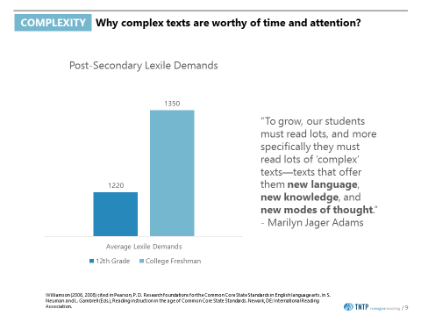

The Developmental Trajectory of Reading Comprehension Skills
Choosing Complex Texts for Read Alouds in Early Childhood

Directions:
- Spend several minutes independently reading the following:
- Pre-K Standards, Standard 2.0 Reading Strategies
- Pre-K Standards, Standard 3.0 Literary Text
- Pre-K Standards, Standard 4.0 Expository Text
- Infant and Toddler Early Learning Guidelines, Pre-Reading and Pre-Writing (for each age group)
- Highlight any standards you notice that pertain specifically to: engaging students with complex texts, using texts in read aloud, and/or reading & listening comprehension across the ages.
- Map the major milestones that students will hit at each age (specifically for engaging with complex texts) in your handouts.
- Be prepared to share your takeaways!
Reading Comprehension Developmental Trajectory:
Birth-1 Year | 1-2 Years | 2-3 Years | 3-4 Years

Worthwhile Texts: Focus Areas in Observations
Choosing Complex Texts for Read Alouds in Early Childhood

FOCUS AREA | OBSERVATION TOOL
Text-Centered | Most the activity is spent listening to, reading, writing, speaking or drawing about text(s).
Complexity | The text(s) are at or above the complexity level expected for the age group and time in the school year.
Knowledge | The text(s) exhibit exceptional craft and thought and/or provide useful information; where appropriate the texts are richly illustrated.

Defining Complex Texts
Choosing Complex Texts for Read Alouds in Early Childhood

FEATURE | DEFINITION | NOTES
Engaging, complex plot | An engaging, complex plot will interest readers and drives their desire to know what happens next, especially in relation to a story’s resolution.  The main idea and problem of the story often need to be inferred; students need to use critical thinking to figure it out.
Round, well-defined characters | Round characters (rather than flat or one-dimensional) are dynamic, changing, and malleable and have clear personalities.  In contrast, flat (stock) characters are stable, fixed, and unresponsive to differences.  Round characters are like real people—they act, think, and speak differently depending on the immediate context
Rich language | Rich language includes words and phrases that develop complex meaning and vivid imagery for the reader. Such text introduces young readers to words that may be new or somewhat unknown, Tier 2 words, as well as to familiar words used in new ways (e.g., figurative language).  Texts with rich language require students to build understanding of the vocabulary and meaning of the words in order to understand the text as a whole.
Engaging, complex illustrations | High-quality narrative picture books involve a blending of text and illustration to construct meaning. The meaning from the text and the illustrations are interconnected so that the whole is greater than the sum of its parts.  Complex illustrations aren’t simply literal interpretations of the text, but often require some other background knowledge or inferences in order to understand their meaning.  Illustrations should be visually interesting and worth examining closely.

Pause & Reflect
Choosing Complex Texts for Read Alouds in Early Childhood

Reflect on the questions below:
Which features of text complexity resonate with you the most?

Are there other features you would include in your definition of complex texts?

Analyzing Complex Texts: Group Practice – Peter’s Chair
Choosing Complex Texts for Read Alouds in Early Childhood

FEATURE | ANALYSIS
Engaging, complex plot | Yes/No/Somewhat  Evidence/Examples:
Round, well-defined characters | Yes/No/Somewhat  Evidence/Examples:
Rich language | Yes/No/Somewhat  Evidence/Examples:
Engaging, complex illustrations | Yes/No/Somewhat  Evidence/Examples:

Analyzing Complex Texts: Independent Practice, Part 1
Choosing Complex Texts for Read Alouds in Early Childhood

FEATURE | ANALYSIS
Engaging, complex plot | Yes/No/Somewhat  Evidence/Examples:
Round, well-defined characters | Yes/No/Somewhat  Evidence/Examples:
Rich language | Yes/No/Somewhat  Evidence/Examples:
Engaging, complex illustrations | Yes/No/Somewhat  Evidence/Examples:

Text Quality
Choosing Complex Texts for Read Alouds in Early Childhood

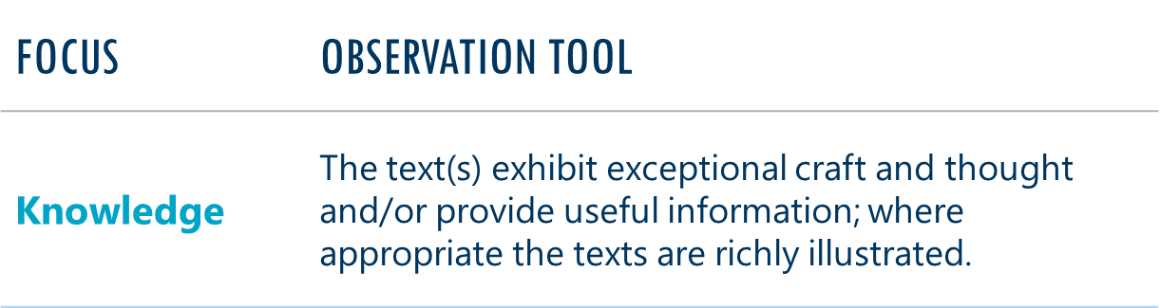

Independent Practice, Part II:
Ask yourself:
- Does the text build students’ knowledge of the world around them? Are texts sequenced in a way that builds deeper knowledge over time, rather than bouncing from topic to topic?

- Is the text worth reading and re-reading? Are there layers of meaning, complex language, etc. that are worth students digging into and exploring?

Putting It All Together
Choosing Complex Texts for Read Alouds in Early Childhood

FEATURE | ANALYSIS
Engaging, complex plot | Yes/No/Somewhat  Evidence/Examples:
Round, well-defined characters | Yes/No/Somewhat  Evidence/Examples:
Rich language | Yes/No/Somewhat  Evidence/Examples:
Engaging, complex illustrations | Yes/No/Somewhat  Evidence/Examples:

- Does the text build students’ knowledge of the world around them? Are texts sequenced in a way that builds deeper knowledge over time, rather than bouncing from topic to topic?

- Is the text worth reading and re-reading? Are there layers of meaning, complex language, etc. that are worth students digging into and exploring?

Reflection
Choosing Complex Texts for Read Alouds in Early Childhood

Reflect on the questions below:
- How will using complex texts in read alouds support student literacy outcomes in your classroom?

Exit Ticket
Choosing Complex Texts for Read Alouds in Early Childhood

- What are your next steps for ensuring that you are consistently choosing complex texts for read alouds?

- How will you hold yourself accountable for doing this?

- What questions do you still have about what you learned today? What feedback do you have about the session for the facilitator?

