Nevada ECE Leadership Series
Session 5

Do Now
Engaging with Vocabulary in Complex Texts

During our teacher development sessions, there has been a distinct focus on building student language and vocabulary skills as well as using complex texts to build student comprehension. In our final session today, we will bring everything together by discussing how we can use complex vocabulary within high-quality texts to continue to build students’ expressive vocabulary and content knowledge.
Reflect on the following questions:
- How does your staff currently teach text-based vocabulary during read alouds?

- How do students practice vocabulary during read alouds?

- How does staff select focus vocabulary to teach through read alouds?

Revisiting the Importance of Vocabulary
Engaging with Vocabulary in Complex Texts

We have spent a significant amount of time focusing on vocabulary in a variety of ways throughout the Leadership Series.

- Why is developing our students’ vocabularies critically important? What is at stake?

- How will you continue to emphasize complex vocabulary in your center or school? In your classrooms?

The Planning Process
Engaging with Vocabulary in Complex Texts

Steps to Selecting Target Vocabulary
Engaging with Vocabulary in Complex Texts

STEP 1 | Identify vocabulary that connects to the big idea of the story
STEP 2 | Identify vocabulary that will build students’ content knowledge on a topic
STEP 3 | Identify vocabulary terms that are complex and high-utility to build student language
STEP 4 | Prioritize the vocabulary that you identified. Which terms will be most important for students to know in order to understand the story? Which vocabulary can be taught more briefly while reading?

Notes from Facilitator Model:
This model will be done using the text What Do You Do With a Tail Like This? by Steve Jenkins and Robin Page.

Partner Practice
Engaging with Vocabulary in Complex Texts

With a partner at your table:
- Choose one book for the two of you to dig into
- Quickly review the book
- Use the steps to select target vocabulary that you would want to teach students during this read aloud
- Be prepared to share and explain your choices!

Text: ___________________________________________________________________________________
Target Vocabulary:

Reflecting on Vocabulary Selection
Engaging with Vocabulary in Complex Texts
How will this process support your teachers in choosing the very best vocabulary to teach their students during read alouds?

How does this connect to work we did earlier in the Leadership Series about promoting complex vocabulary through conversation and self- and parallel-talk?

When Should I Plan to Teach Vocabulary?
Engaging with Vocabulary in Complex Texts

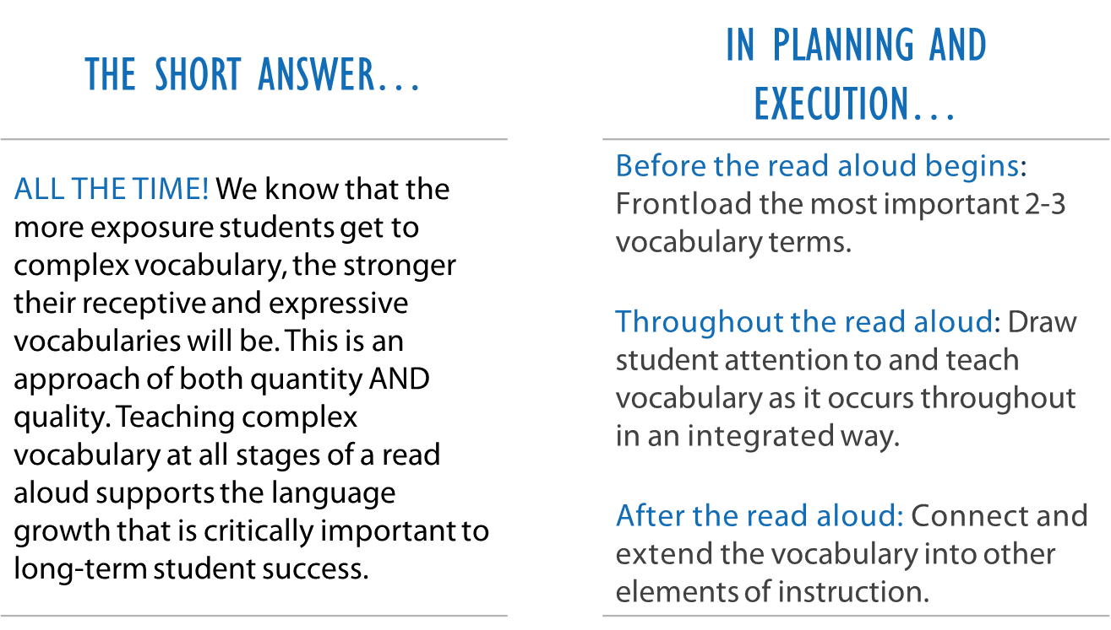

Before: Frontloading
Engaging with Vocabulary in Complex Texts
Key Idea: Frontloading is when we select 2-3 vocabulary words that students will need the most in order to understand the text. These select words should be the highest utility to add to their vocabulary.

When we Frontload:

- We expose students repeatedly to the word itself, as well as a tangible or photographic example of that vocabulary word so they can visualize it.
- Then, repeat the vocabulary word several times and have students chorally articulate the word as well.
- If any of the words lend themselves to acting them out, demonstrate the words through acting and have students join in as well.

During: PAT the Vocabulary
Engaging with Vocabulary in Complex Texts

Key Idea: Key Idea: The Atlanta Speech School designed a highly effective strategy for teaching vocabulary authentically and intentionally throughout a read aloud called "PAT" the vocabulary.
PAT is an acronym that stands for:
- Point: to illustrations in the book that match the vocabulary
- Act: out words whose meanings can be shown through action or facial expressions
- Tell: the meaning of words that need to be defined to understand the story
When we “PAT” the vocabulary:
- First, flag additional vocabulary that you want to briefly highlight or explain in an integrated way during your reading of the text.
- Then, decide if you will point, act, or tell that word to your students. Have students engage with the vocabulary as well by chorally repeating the word, definition, and/or actions.

During: Text-Based Vocabulary Questions
Engaging with Vocabulary in Complex Texts

Key Idea: We already know that it is critical to have strong text-based questions so that students can engage with the content and big ideas within complex texts.

It is equally important to design questions that engage students specifically around vocabulary so that they have the opportunity to practice using and understanding target vocabulary to build content knowledge and vocabulary.

To write text-based vocabulary questions:
- Identify the vocabulary words that are most important for students to understand in order to engage with the content in the text.
- Write questions that:
- Include those vocabulary terms and ask students to use them in their response.
- Ask students to define or explain the vocabulary words.
- Ask students to apply those vocabulary terms in their thinking about the text (can also be integrated into a text-based content question).
Sample text-based vocabulary questions:

After: Extending
Engaging with Vocabulary in Complex Texts

Key Idea: Make sure the vocabulary that was highlighted continues throughout the day!
When we Extend the vocabulary:
- Initiate conversations with students that include that vocabulary
- Continue to utilize the vocabulary yourself so students continue to hear it
- Set up independent and guided learning activities that prompt students to utilize that vocabulary
- Make the vocabulary known to families so it can be reinforced at home

Planning to Teach Vocabulary in What Do You Do With A Tail Like This?
Engaging with Vocabulary in Complex Texts

Time of Read Aloud | Target Vocabulary | How Students Will Be Exposed and Practice
Before Reading | Capture  Leap  Squirt  Sting | Frontloading:  Students will hear and repeat each vocabulary word several times  Students will see an accompanying picture of the vocabulary word  Students will act out each vocabulary word by:  - Pretending to “capture” something in the air  - Standing and taking a “leap” away from the carpet  - Pretending to “squirt” a ketchup bottle  - Pretending to be a bee and “sting”ing their leg
During Reading | Underground  Pesky  Stinky  Tiny  Clearly  Ledge | PAT the Vocabulary:  Underground, or “beneath the dirt” (point to picture)  Pesky, or “annoying”  Stinky, or “really smelly” (pinch nose)  Tiny, or “very, very small” (make very small motion with fingers)  Clearly, or “very well”  Ledge, or “cliff” (point to picture)  Text-Based Vocabulary Questions:  Why do you think moles make their way underground? What must it be like down there?  Why do mountain goats have to do so much leaping? What in the picture helped you figure that out?  What might it look like to “capture” something?
After Reading | All vocabulary from above | Extend:  - Students will be prompted to act out, draw, or write about all vocabulary in centers  - Words will be posted on our unit vocabulary well and used repeatedly by staff  - Students will choose one verb to act out from “before reading” when transitioning, lining up, etc.  - Closing activity will be vocabulary charades during closing circle

Planning to Teach Vocabulary: Independent Practice
Engaging with Vocabulary in Complex Texts

Before Reading | Frontloading:
During Reading | PAT the Vocabulary:  Text-Based Vocabulary Questions:
After Reading | Extend:

Leader Planning Time/Exit Ticket
Engaging with Vocabulary in Complex Texts

Take the next several minutes to create a plan for how you will take this content back to your team.
- What are your key takeaways about designing and using text-based vocabulary?

- How will you support your teachers in using text-based vocabulary in their daily read alouds? What tools will you create and provide them with?

- What are you excited about and what challenges do you anticipate?

- When and how will you deliver this content to your staff?

Next Steps
Closing and Reflection

Prior to Session 6 Leadership Series training:
Session Delivery:
- Implement the teacher development session: Choosing and Using Complex Texts in Early Childhood (if you haven’t already)
- Collect the exit tickets from the session. Bring those exit tickets to Session 6.
- As you observe teachers during read alouds, note which books they’re reading and if they meet the criteria for being a complex text.
Teacher Observations:
- Input any current teacher observation data that you may have not gotten to during our time together today.
- Observe and rate three teachers.
  - Complete an individual observation report for each teacher.
  - Hone in on a key development lever for each teacher, script the opening of the coaching conversation, the model and practice portions. Execute the three coaching conversations.
  - Bring observation reports and coaching conversation notes for those three teachers to Session 6.
  - Continue to conduct observations, record ratings, and lead coaching conversations for all teachers. Enter ratings regularly into your trackers. (No need to complete full observation reports for all observations.)

