Do Now
Building Oral Language: Promoting Complex Vocabulary Using Self- and Parallel-Talk

“In four years, an average child in a professional family would accumulate experience with almost 45 million words, an average child in a working-class family 26 million words, and an average child in a welfare family 13 million words.”

For pre-work, you read “The Fight to Boost Student Literacy is Happening Years Too Late” by Conor Williams. Using your knowledge of that article and the quote above, respond to the following questions:

- Why is it so urgent that our students are exposed to rich and varied vocabulary beginning from birth?

- What are you and your teachers already doing to promote language acquisition in your students? Where do you wish you were doing more?

The 30 Million Word Gap
Building Oral Language: Promoting Complex Vocabulary Using Self- and Parallel-Talk

After watching the video presentation, “Imprisoned by Illiteracy”, reflect on the following questions:
- What are your initial reactions to the presentation?

- What does this mean that many of our children are up against?

- What can be done at the school, center, and classroom level to break this cycle of illiteracy?

The Oral Language Developmental Trajectory
Building Oral Language: Promoting Complex Vocabulary Using Self- and Parallel-Talk

Directions:
- Spend several minutes independently reading the Oral Language standards and Vocabulary standards in the Infant and Toddler Early Learning Guidelines and the Pre-Kindergarten Standards.
- Highlight any standards you notice that pertain specifically to vocabulary acquisition and development across the ages.
- Map the major milestones that students will hit at each age (relating specifically to oral language and vocabulary) below.
- Be prepared to share your takeaways!
Language and Vocabulary Developmental Trajectory:
BIRTH – 1 YEAR | 1-2 YEARS | 2-3 YEARS | 3-4 YEARS

Three Key Literacy Experiences and Vocabulary Tiers
Building Oral Language: Promoting Complex Vocabulary Using Self- and Parallel-Talk

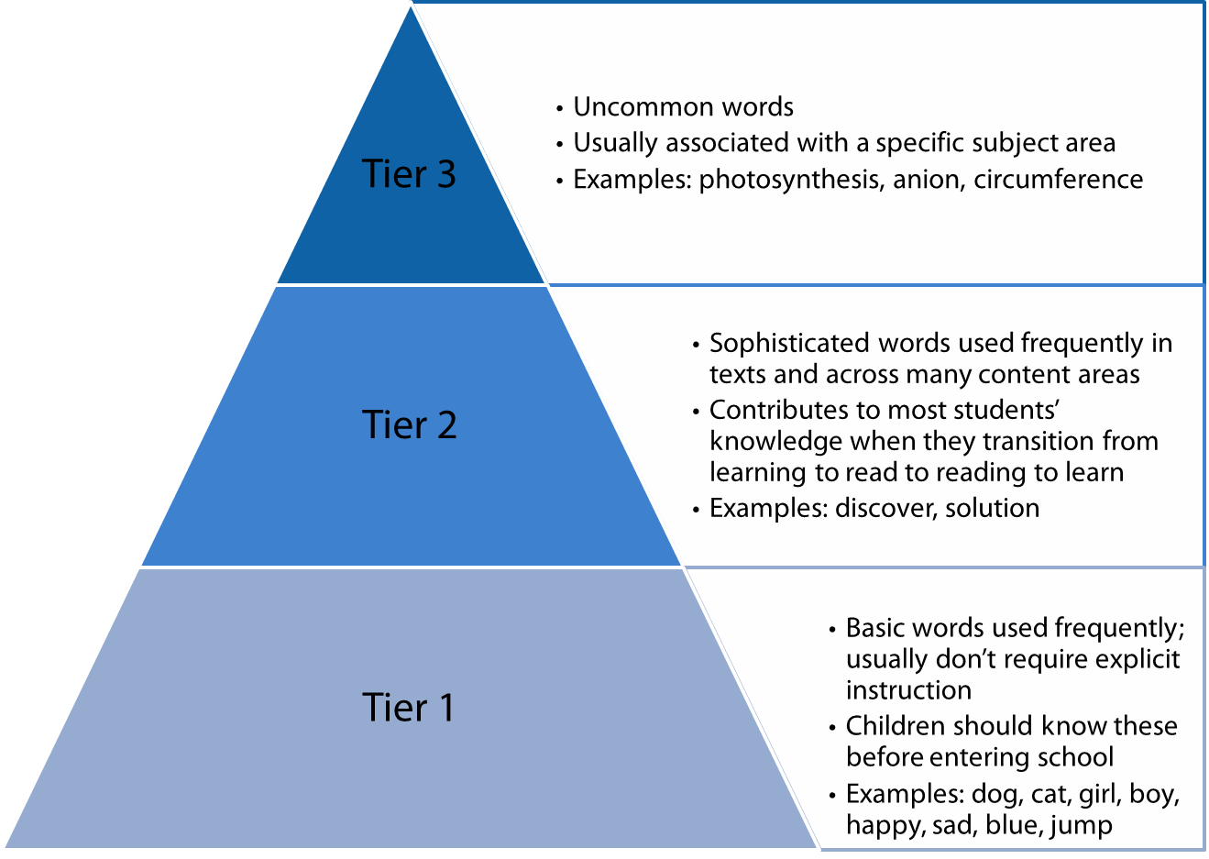

Selecting the Right Complex Vocabulary
Building Oral Language: Promoting Complex Vocabulary Using Self- and Parallel-Talk

Key Idea: Exposing students to complex vocabulary should happen constantly throughout the day. It’s not enough, however, to incorporate complex language without intentionality. It’s essential that we expose our students to the right complex vocabulary.
IS IT USEFUL AND IMPORTANT? | CAN IT BE TAUGHT? | WILL IT HELP TEACH IDEAS? | DO YOU HAVE VARIETY?
Will they see or hear the word often?  Will understanding this word help them be able to express themselves or to understand what others are saying?  Will it help them comprehend a text that we are reading? | Can you teach the word in a way that children will understand?  Are you able to define the word using other words/text/movement/pictures that children can understand? | Is this connected to a current theme or big idea we are working on in our classroom?  Will this help students make sense of the larger world? | Do I have a variety of different kinds of words (nouns, adjectives, verbs, adverbs) that will expand student vocabulary in a variety of contexts?

Directions: Take 5 minutes to review the Complex Vocabulary list on the next page and highlight 5-10 words that you would want teachers to promote (and students to know and use) that align to your vision for your center or school.
Use the guiding questions above to help you pick strong complex vocabulary examples.

Complex Vocabulary Word List
Building Oral Language: Promoting Complex Vocabulary Using Self- and Parallel-Talk

Feeling Words
disappointed
annoyed
thankful
delighted
frustrated
proud
curious
furious
irritable
exhausted
relieved
confused
terrified
astonished

Nouns
shadow
reflection
schedule
envelope
pond
swamp
relative
sibling
adventure
journey
neighborhood
predator
invitation
row
stack
meadow
instant
variety
envy
list

Verbs
absorb
admire
arrange
argue
assist
attach
avoid
comfort
cover
ignore
imitate
invite
outgrow
practice
regret
rescue
impress
identify
recognize
realize
explore
examine
investigate
create
remain
remove
transform
contain
convince
suggest
locate
receive
prefer
combine
protect
transport
appear
search
blend
separate
disappear
melt
introduce
concentrate
dream
imagine
assign
complete
pretend
Adjectives
edible
comfortable
complicated
difficult
dependent
elegant
determined
enormous
useful
powerful
independent
familiar
unexpected
available
sudden
same
different
strange
unusual
ordinary
pleasant
cautious
favorite
empty
humorous
serious

Adverbs
especially
daily
quickly
suddenly
patiently
prepositions
except
beneath
above
between
beside
Strategies for Promoting Complex Vocabulary
Building Oral Language: Promoting Complex Vocabulary Using Self- and Parallel-Talk

Key Idea: Students don’t simply learn complex vocabulary. Complex language needs to be intentionally incorporated into every interaction students have with adults in their classrooms.

STRATEGIES | DEFINITIONS
Self-Talk | Talk about what you are doing, seeing, eating, touching, or thinking constantly throughout the day when working or conversing with students. In other words, narrate your actions, incorporating complex vocabulary throughout.
Parallel-Talk | Talk about what your student or students are doing, seeing, eating, or touching. In other words, narrate what they are doing, incorporating complex vocabulary throughout.

Video Analysis: As you watch the classroom video, take notes below on where you see the teacher use self- and parallel-talk, and what vocabulary she might be emphasizing.

Practice Promoting Complex Vocabulary with Self- and Parallel-Talk
Building Oral Language: Promoting Complex Vocabulary Using Self- and Parallel-Talk
Planning Directions:
- Imagine you are popping into a two-, three-, or four-year-old classroom during center time. Students are engaged in a writing center, a library center, and a science center.
- Write one self-talk sentence and one parallel-talk sentence that you could use with students in each center.
 | PARALLEL-TALK | SELF-TALK
Writing Center
Library Center
Science Center

Practice Directions:
- With the person sitting next to you, practice delivering your sentences as though one of you is the leader and the other is the student.
- If you are the leader, you will practice delivering your self- and parallel-talk sentences to your “student” as though you are in the centers above. If you are the student, you will silently pretend to be playing and working alongside the leader.
Feedback Directions:
- After the first leader practices their self- and parallel-talk sentences, the “student” will provide feedback (one glow, one grow) to the leader using the self- and parallel-talk cheat sheets.
- After providing feedback, the roles will switch and the other partner will become the leader.
- Use the sentence frame, “Great job with __________________________. Next time try __________________.”

Self- and Parallel-Talk Cheat Sheet
Building Oral Language: Promoting Complex Vocabulary Using Self- and Parallel-Talk

 | CRITERIA
Self-Talk | - Talk about what you are doing, seeing, eating, touching, or thinking  - Narrate your own actions with complex vocabulary
Parallel-Talk | - Talk about what student(s) are doing, seeing, eating, touching, or thinking  - Narrate your students’ actions with complex vocabulary
Complex Vocabulary | - Use complex vocabulary during all narrations and conversations  - Vocabulary is varied and relevant  - Vocabulary is useful and important  - Vocabulary can be taught in an easy and student-friendly way  - Vocabulary will help teach ideas  - Includes vocabulary from different word groups (nouns, adjectives, etc.)
Student-Teacher Interactions | - Stay focused on students throughout the interaction  - Promote both quantity and quality of language  - Use warm, child-friendly tone and body language  - Interactions between teachers and students are positive, driven by student interest and student work/play, and are NOT focused on behavioral redirections

Overcoming the Get It-Do It Gap
Building Oral Language: Promoting Complex Vocabulary Using Self- and Parallel-Talk

The Get It-Do It Gap refers to the difference between cognitively understanding something and actually putting it into practice successfully.

Brainstorm responses to the two questions below:
What can we do or put in place to ensure that teachers not only understand the importance of promoting complex vocabulary constantly throughout the day, but actually follow through in doing it?

What can we do or put in place to ensure teachers are using self- and parallel-talk as key strategies to teach complex vocabulary?

Exit Ticket
Building Oral Language: Promoting Complex Vocabulary Using Self- and Parallel-Talk

What are your next steps for ensuring that you are constantly and intentionally exposing your students to complex vocabulary?

When and where will you increase your use of self- and parallel-talk? How will you hold yourself accountable for using these strategies?

What questions do you still have about what you learned today?

What feedback to you have about the session for the facilitator?

